C:\Users\anreinhardt\Desktop\Logo_FAPS.wmfDevelopment of A Parametric Tool for Automated

Slot Insulation Insertion in Small-Scale Electric-

Motor Stator Production

Project Thesis in study program Electromobility ACES

Friedrich-Alexander-Universität Erlangen-Nürnberg  
Lehrstuhl für Fertigungsautomatisierung und Produktionssystematik  
Prof. Dr.-Ing. Jörg Franke

Hier aussagekräftiges Bild einfügen, welches den Inhalt der Arbeit

darstellt. Bild vor den Text positionieren, um ein Verschieben der unteren Angaben zu

verhindern (Rechtsklick auf Bild, Zeilenumbruch, hinter den Text).

Bildbreite: 16,88 cm (bündig mit Logo)

Bearbeiter: Alen Sebastian, 23221507

Betreuer: Prof. Dr.-Ing. Jörg Franke  
 Valentin Henrich

Abgabetermin: 31.08.2025  
Bearbeitungszeit: 6 Months

Erklärung

Ich versichere, dass ich die Arbeit ohne fremde Hilfe und ohne Benutzung anderer als der angegebenen Quellen angefertigt habe und dass die Arbeit in gleicher oder ähnlicher Form noch keiner anderen Prüfungsbehörde vorgelegen hat und von dieser als Teil einer Prüfungsleistung angenommen wurde. Alle Ausführungen, die wörtlich oder sinngemäß übernommen wurden, sind als solche gekennzeichnet.

Erlangen/Nürnberg, den XX.XX.202X

Alen Sebastian

ABSTRACT

The customer specific manufacturing of stators for electric motors in small-scale production is based on a time-consuming and expensive process chain. For this reason, the Institute for Factory Automation and Production Systems (FAPS) from Friedrich-Alexander University Erlangen-Nuremberg (FAU) is researching on solutions centered on the flexible automation of these processes. This paper presents a parametric mechanical tool designed for the robotic-based insertion of slot insulation paper in electric motors. While this task is predominantly performed manually in small-scale production, the proposed tool offers a flexible solution for automation. The tool's parametric design supports fast customization for different stator variants. Given the limited profit margin, the cost-efficiency of the solution is a key factor in its development. The main goal is to improve flexibility in assembling different variants, small batch sizes and customer specifications.

Table Of Contents

[ABSTRACT 4](#_Toc207045404)

[Table Of Contents I](#_Toc207045405)

[1 Introduction and objectives 6](#_Toc207045406)

[1.1 Motivation 6](#_Toc207045407)

[1.2 Vision 8](#_Toc207045408)

[1.3 Problem Statement 8](#_Toc207045409)

[1.4 Structure of the thesis 8](#_Toc207045410)

[2 Fundamentals of Electric Motor Production 9](#_Toc207045411)

[2.1 Motor Types and Construction Principles 9](#_Toc207045412)

[2.1.1 DC Motors 9](#_Toc207045413)

[2.1.2 AC Motors 10](#_Toc207045414)

[2.1.3 Synchronous Motors 11](#_Toc207045415)

[2.1.4 Asynchronous Motors 11](#_Toc207045416)

[2.2 Rotor Assembly 12](#_Toc207045417)

[2.3 Stator Assembly 13](#_Toc207045418)

[2.4 Slot liner function and Importance 15](#_Toc207045419)

[3 Robotic Systems for Insertion Tasks 17](#_Toc207045420)

[3.1 Suitable Robot Types 17](#_Toc207045421)

[3.2 Kinematics and Motion Control Principles 18](#_Toc207045422)

[3.3 End Effector Requirements 20](#_Toc207045423)

[3.4 Sensors and Actuators in Robotic Insertion Tasks 20](#_Toc207045424)

[3.4.1 Electric Grippers for Precision Handling 21](#_Toc207045425)

[3.4.2 Role of Actuators in Precision Insertion Tasks 22](#_Toc207045426)

[3.4.3 Overview of Sensors in Automation 22](#_Toc207045427)

[3.4.4 Force-Torque Sensors for compliant control 24](#_Toc207045428)

[3.4.5 Safety and Human Robot Interaction 25](#_Toc207045429)

[3.5 Programming Methods in Robotic Automation 26](#_Toc207045430)

[3.5.1 Programming Using Teach Pendant and Manual Inputs 27](#_Toc207045431)

[3.5.2 Implementation of UR Script 28](#_Toc207045432)

[3.5.3 Programming using ROS 29](#_Toc207045433)

[3.5.4 Integration of Sensor Feedback 30](#_Toc207045434)

[4 Methodology 32](#_Toc207045435)

[4.1 Research Approach and Iterative Process 32](#_Toc207045436)

[4.2 Observation, Challenges, and Development of Automation Approach for Slot Liner Insertion 33](#_Toc207045437)

[4.3 Testing Strategy and Evaluation Criteria 33](#_Toc207045438)

[5 Automation of Slot Liner insertion in Motor `Manufacturing 35](#_Toc207045439)

[5.1 Common Challenges in the Insertion Process 35](#_Toc207045440)

[5.2 Large Scale vs Small Scale Production Strategies 36](#_Toc207045441)

[5.3 Automation Principles 37](#_Toc207045442)

[5.3.1 Design for flexible automation 37](#_Toc207045443)

[5.3.2 Variety in Stator Design for Slot Liner insertion 38](#_Toc207045444)

[5.3.3 Influence on Insertion tooling and strategies 39](#_Toc207045445)

[6 Hardware setup for flexible slot liner insertion 41](#_Toc207045446)

[6.1 Robotic Module 41](#_Toc207045447)

[6.1.1 UR10e Co-bot 42](#_Toc207045448)

[6.1.2 RG2 Gripper 43](#_Toc207045449)

[6.1.3 HEX Force-Torque Sensor 44](#_Toc207045450)

[6.2 Rotating Clamp for Stator Alignment 44](#_Toc207045451)

[6.3 Tool and Slot Liner Placement Platform 45](#_Toc207045452)

[7 Parametric tool for flexible slot liner insertion 47](#_Toc207045453)

[7.1 Selection of Required adjustable parameters 47](#_Toc207045454)

[7.2 Fundamental Tool design 48](#_Toc207045455)

[7.2.1 Initial Tool model and design considerations. 49](#_Toc207045456)

[7.2.2 Observations and Limitations of the Initial Prototype 52](#_Toc207045457)

[7.3 Final design 53](#_Toc207045458)

[7.4 Fitting Adjustable Parameters for Specific Use Cases 55](#_Toc207045459)

[8 PARAMETRIC SLOT LINER INSERTION PIPELINE 57](#_Toc207045460)

[8.1 Funnel Application 57](#_Toc207045461)

[8.2 Slot Liner Positioning and Partial Insertion 57](#_Toc207045462)

[8.3 Final Liner Insertion 57](#_Toc207045463)

[8.4 UR Script Based Insertion Control 58](#_Toc207045464)

[9 Tool Process Testing and Validation 59](#_Toc207045465)

[9.1 Testing results 59](#_Toc207045466)

[9.2 Stator A 60](#_Toc207045467)

[9.3 Stator B 61](#_Toc207045468)

[9.4 Stator C 62](#_Toc207045469)

[10 Result Discussion 63](#_Toc207045470)

[11 Outlook 64](#_Toc207045471)

[12 References 66](#_Toc207045472)

Table of Figures

[Figure 1‑1: Global CO2 emissions from 1970 to 2020, grouped by vehicle and fuel type [2] 7](#_Toc206070717)

[Figure 2‑1: Overview of insulating and supporting parts in a low-voltage insulation system [6] 9](#_Toc206070718)

[Figure 2‑2: Stator slot in (a) detail model (motor-cad) and the (b) actual stator slot [8] 11](#_Toc206070719)

[Figure 2‑7: Examples of common industrial robot configurations used in manufacturing and automation. 12](#_Toc206070720)

[Figure 2‑8: DH parameter calculation in a Universal Robot [28] 14](#_Toc206070721)

[Figure 2‑9: Different Gripper configurations provided by OnRobot [33] 16](#_Toc206070722)

[Figure 2‑10: Various sensors used in automation 18](#_Toc206070723)

[Figure 2‑11: Force Torque Sensor with gripper installed on a Robotic arm [42] 20](#_Toc206070724)

[Figure 2‑8: Results of human–robot collaboration experiments. (a) and (b) depict human task coordination by visual detection of the left wrist (handLeft), for halting the robot and performing manual assembly actions (a), followed by right wrist detection (handRight) [44] 21](#_Toc206070725)

[Figure 2‑13: UR Teach Pendant (Insert own image) 22](#_Toc206070726)

[Figure 2‑14: Example of a URScript program to initialize a camera, take a snapshot and retrieve a new target pose [48] 23](#_Toc206070727)

[Figure 2‑15: A typical ROS network configuration [49] 24](#_Toc206070728)

[Figure 3‑1: Technical specifications of NIDE slot liner insertion machine [13] 28](#_Toc206070729)

[Figure 2‑4: Adjustable grooving module with two gear-coupled rotating shafts [16] 29](#_Toc206070730)

[Figure 2‑5: Four typical stator configurations [20] 31](#_Toc206070731)

[Figure 3‑4: Cutaway view of a stator slot showing the arrangement of insulation materials and components [21] 33](#_Toc206070732)

Table of Abbreviations

ICE Internal Combustion Engines

PLDV Passenger Light Duty Vehicle

CLDV Commercial Light Duty Vehicle  
ASM Asynchronous Motor

PMSM Permanent Magnet Synchronous Motor

Cobot Collaborative Robot

RTD Resistance Temperature Detection

FT Sensors Force-Torque Sensors

HRI Human Robot Interaction

# Introduction and objectives

The continued evolution of electric motor technologies is closely tied to advancements in manufacturing, automation and process optimization. As industries gradually transition towards electrification, particularly in the transportation sector, there is a growing need for adaptable systems that support efficient and scalable motor production. This thesis addresses on one such area by focusing on the development of a parametric tool for automated slot insulation insertion in small scale electric motor production. The goal is to enhance flexibility, precision and repeatability in a process that is often manual and time consuming.

## Motivation

For over a century, internal combustion engines (ICEs) shaped the course of transportation and industrial growth, powering everything from personal vehicles to heavy machinery and global logistics. Their dominance was built on several key advantages: mechanical simplicity, robust performance, relatively low production costs, and a well-established global refueling infrastructure. These engines enabled rapid mobility, supported economic expansion, and became a critical driver of technological innovation in the automotive and energy sectors. From long-haul freight to aviation and agriculture, ICEs provided the flexibility and power density necessary for a wide range of demanding applications, earning their place as the backbone of modern industry and everyday life. However, as their usage proliferated worldwide, the long-term environmental consequences proved to be far greater than initially anticipated. In particular, the extensive combustion of fossil fuels in ICEs has led to the dramatic rise in greenhouse gases, especially CO2, which is widely recognized as the primary driver of human induced climatic change.

About 23% of global CO₂ emissions are attributed to the transportation sector, making it one of the largest contributors to climate change. Within this sector, freight transportation plays a particularly significant role, often generating more emissions than passenger transport on a per-vehicle or per-kilometer basis. The majority of these emissions come from diesel-fueled heavy-duty trucks, which dominate freight transport and contribute heavily to environmental pollution [1]. As shown in Fig. 1-1, in the past few decades, global CO₂ emissions from on-road vehicles increased from 1.7 Gt to 5.4 Gt, driven largely by the expansion of the vehicle fleet, especially in emerging economies. In 2020 alone, Internal Combustion Engine (ICE) vehicles emitted approximately 3.2 Gt of CO₂ globally.. Passenger Light-Duty Vehicles (PLDVs), mostly gasoline-powered, were the top contributors in absolute terms, accounting for almost half of on-road emissions, largely due to their sheer number. Diesel-powered trucks, made up a significantly less portion of the fleet but produced 22% of emissions, making them the second-largest contributors and highlighting their disproportionately high emissions relative to fleet size. Commercial Light-Duty Vehicles (CLDVs), often used for urban goods transport, also contributed notably, particularly as part of the broader shift towards diesel powered vehicles, although their emissions are often aggregated with PLDVs. [2]

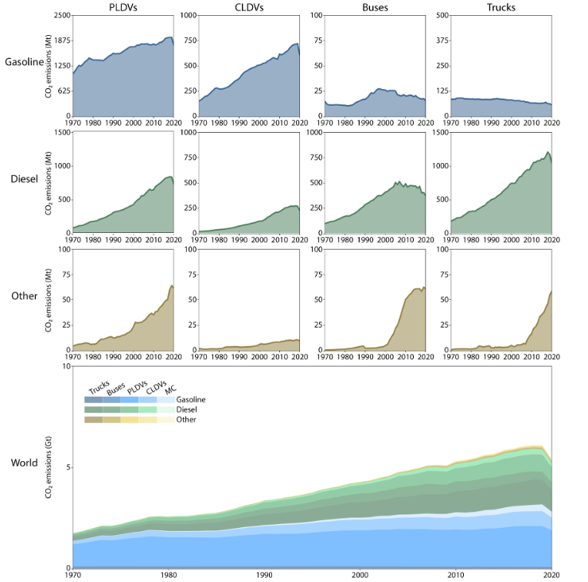

Figure 1‑: Global CO2 emissions from 1970 to 2020, grouped by vehicle and fuel type [2]

In addition to contributing significantly to climate change, ICE vehicles are also major sources of air pollutants such as fine particulate matter (PM2.5), which poses serious risks to human health. Despite individuals spending only a fraction of their time in traffic, their exposure to harmful emissions during this period is disproportionately high, especially in congested urban environments. These health impacts translate into substantial societal costs in the form of healthcare expenses. While many regions are implementing stricter emission policies, the continued reliance on ICEs remains a significant barrier to improving air quality and public health [3]. This further underscores the urgency of developing cleaner, more efficient alternatives, such as electric vehicles-supported by scalable manufacturing technologies.

## Vision

The shift to electrification is not only about changing the energy source, it demands a complete rethinking of how these systems are designed and built. The manufacturing of electric motors, though less complex in moving parts than combustion engines, introduces new challenges in precision, scalability, and material handling. One such challenge is the insulation of stator slots, a critical step that influences motor performance, reliability and safety. To meet the increasing demand for high-quality motors at scale, automation of this process is essential. This project contributes to the broader vision of smart manufacturing by addressing one such bottleneck.

## Problem Statement

The goal of this project is to automate a specific step in the assembly of a pre-manufactured stator, namely, the robot-assisted insertion of slot liners into the stator slots. Currently this process is done manually, especially for small batch sizes. The core focus of this thesis is the development of a tool that enables reliable and repeatable insertion of the slot liners. Furthermore, the functionality and performance of the system will be optimized and validated within an automated robotic setup.

## Structure of the thesis

This thesis is structured into eight chapters. Chapter 1 introduces the motivation, vision, and the specific problem addressed in this work. Chapter 2 presents the theoretical background and reviews the current state of the art in motor manufacturing, slot liner insertion, and robotics. Chapter 3 provides an overview of the hardware components used for testing and validating the proposed parametric tool, while Chapter 4 focuses on its design and key features. Chapter 5 describes the implementation process, detailing the applied methodology, and a critical discussion of each step. Chapter 6 addresses the validation process and success rate of the tool based on multiple trials conducted. Finally, Chapters 7 and 8 present the results and offer an outlook on future developments.

# Fundamentals of Electric Motor Production

Electric motors are fundamental components in a wide range of applications, and their production is undergoing a profound transformation to meet growing demand. While highly standardized and automated processes dominate large-scale production, such as in the automotive sector [4], small-scale and custom manufacturing remains prevalent in industries like marine propulsion, where motors are tailored to specific operational requirements [5]. To fully understand the nuances of these production approaches, it is essential to first examine the different motor types and their construction principles, as these directly shape both manufacturing methods and performance outcomes.

## Motor Types and Construction Principles

Electric motors are broadly classified into Direct Current (DC) and Alternating Current (AC) types, with each category defined by construction features that influence both performance and manufacturing methods. In addition to these main groups, there are special-purpose designs such as stepper motors, which move in discrete angular steps, and servo motors, which incorporate position feedback for precision control. These motors are widely used in robotics, CNC machinery, and instrumentation, and they are typically produced in smaller volumes with a higher degree of customization. By contrast, mass-produced designs like squirrel-cage induction motors prioritize efficiency and scalability, while bespoke high-torque synchronous machines are developed for demanding applications. The choice of motor type ultimately determines the materials and winding methods used, the level of manufacturing automation, the scope for customization, and the extent of integration with control electronics.[6, 7].

### DC Motors

DC motors are generally classified into two main categories: brushed and brushless. Brushed DC motors use a rotor with wound coils, a commutator, and brushes that mechanically switch current through the windings to produce torque against permanent magnets in the stator. They are inexpensive, simple to operate with a direct DC supply, and easy to manufacture, which makes them common in applications such as toys, small appliances, and automotive systems like power windows and seat adjusters. Their disadvantages include mechanical wear of brushes and commutator, sparking that creates electrical noise, torque ripple caused by abrupt current switching, and moderate efficiency, all of which reduce their lifespan and performance.

Brushless DC (BLDC) motors avoid these issues by placing permanent magnets on the rotor and using electronic commutation of stator windings. Rotor position is determined either through sensors such as Hall devices or through estimation techniques based on back electromotive force, with advanced methods like Field-Oriented Control enabling highly precise operation. This design provides higher efficiency, longer service life, smoother torque, lower noise, and better speed and acceleration characteristics. The main drawback of BLDC motors is the need for more complex and costly drive electronics, which include microcontrollers and switching circuits. Brushed DC motors therefore remain practical for low-cost, low-duty applications, while brushless designs have become the preferred choice for modern systems that demand reliability, efficiency, and precision.Figure 2-1 illustrates the main differences between a Brushed and Brushless DC motor [8]

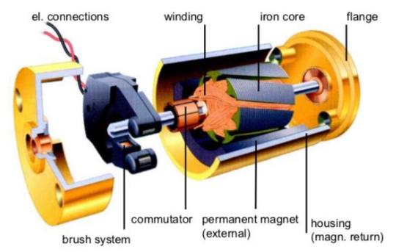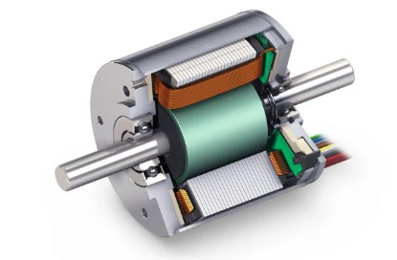

Figure 2‑: Comparison of the internal structure of (a) brushed DC motor—showing the commutator, windings, and brushes—and (b) brushless DC motor, highlighting the absence of brushes and different arrangement of windings.

a) Brushed DC motors

b) Brushless DC motors

### AC Motors

AC motors can be broadly classified into synchronous and asynchronous (induction) motors. Synchronous motors, including permanent magnet synchronous motors (PMSM) and reluctance motors, operate with the rotor’s magnetic field locked in with the stator’s rotating field. These motors require precise rotor construction and often advanced control electronics, which makes them well-suited for high-efficiency, high-precision, and demanding applications. Asynchronous motors, commonly known as induction motors, generate torque when the rotating magnetic field in the stator induces currents in the rotor. They are typically built with a laminated steel stator core and copper or aluminum windings, with either a squirrel-cage or wound-rotor design. Squirrel-cage induction motors are especially favored for high-volume automated production and are widely used in industrial and automotive applications due to their robustness, simplicity, and reliability. [6, 7].. The main differences between Induction motor, Interior Permanent Magnet motor and Surface mounted Permanent Magnetic motor is shown in Figure 2-2. The following sections examines the specific operating principles, constructional features, and application domains of synchronous and asynchronous motors in greater detail.

### Synchronous Motors

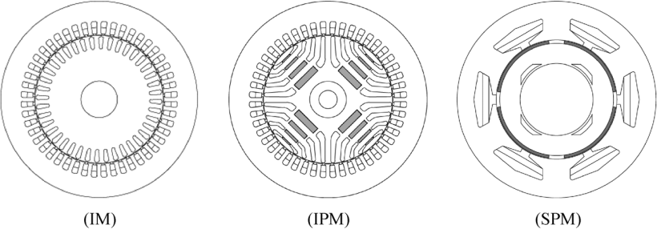

Figure 2‑: Illustration of - Induction motor, Interior Permanent Magnet motor and Surface mounted Permanent Magnetic motor. [9]

Synchronous motors are a class of electric motors in which the rotor rotates at the same frequency as the supplied AC current, ensuring precise synchronization between the motor’s speed and the frequency of the power source. These motors commonly use permanent magnets to generate the rotor's magnetic field. Two main types are widely utilized: surface-mounted permanent-magnet (SPM) synchronous motors, which have magnets mounted on the rotor surface and are known for their simple construction, and interior permanent-magnet (IPM) synchronous motors, where the magnets are embedded within the rotor to create multiple flux barriers and higher saliency. SPM motors offer ease of manufacturing and short end connections, while IPM motors provide superior torque overload capability, enhanced efficiency across a wide speed range, and improved safety and temperature resilience due to their rotor design. Both types require specialized control algorithms, especially for flux-weakening operation, to maximize performance in demanding applications such as electric vehicle traction. [9]

### Asynchronous Motors

Induction motors, also known as asynchronous motors, are a widely used type of AC motor characterized by their robust and simple construction. In these motors, torque is produced through electromagnetic induction, where the rotating magnetic field of the stator induces current in the rotor. Unlike synchronous motors, the rotor of an induction motor rotates at a speed slightly less than the stator’s rotating magnetic field, causing a small slip that is essential for torque generation. There are two main types of induction motors: squirrel cage and slip ring (wound rotor) motors. Squirrel cage motors have a rotor composed of conductive bars short-circuited by end rings, making them durable, cost-effective, and maintenance-free, which makes them highly popular in many industrial and traction applications. Slip ring motors, on the other hand, have rotor windings connected through slip rings, allowing external control of rotor resistance, which provides higher starting torque and variable speed control capabilities. While induction motors are generally less efficient and have lower torque density than permanent-magnet synchronous motors, they are valued for their reliability and safety, owing to natural de-excitation during inverter faults and overall cost-effectiveness, making them a preferred choice for various electric vehicle and industrial drive applications. [9, 10]

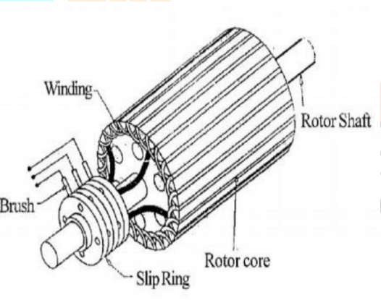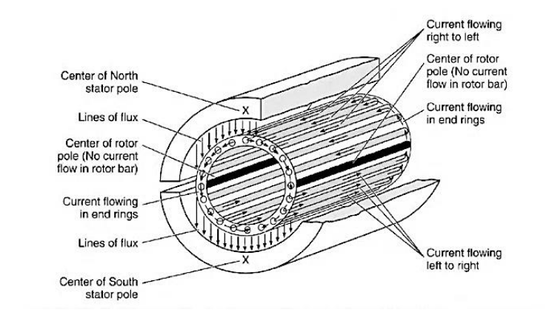

Figure 2‑: Cross-sectional view of a squirrel cage motor and cutaway view of a slip ring motor. [10]

b) Slip ring motor

a) Squirrel cage motor

## Rotor Assembly

The production of electric motor rotors is a highly specialized process that combines advanced materials engineering and precision manufacturing techniques. At its core, the rotor consists of a laminated stack of electrical steel sheets, meticulously punched and coated with insulating layers such as varnish or oxide films to reduce eddy current losses during operation. These laminations are then tightly stacked and secured, preserving alignment and structural integrity. The rotor shaft undergoes precision machining before being assembled with the laminated core, ensuring robust mechanical connection and balance. For asynchronous (induction) motors, the rotor features a cage formed by pressure die-casting molten aluminum or copper into slots around the rotor laminated core and forming end rings in one integrated step, which provides strong electrical conductivity and mechanical durability. Conversely, permanent magnet synchronous motors (PMSMs) incorporate either surface-mounted magnets adhered to the rotor’s exterior or embedded magnets placed within rotor slots, both of which are carefully fixed using adhesives, retaining sleeves, or molded resins to withstand mechanical stresses and centrifugal forces at high rotational speeds. Following assembly, the complete rotor assembly undergoes dynamic balancing to minimize vibrations and is subjected to final dimensional, mechanical, and electrical testing to ensure compliance with stringent quality standards. This comprehensive manufacturing approach achieves an optimized balance between electromagnetic performance, mechanical reliability, and cost-effectiveness, tailored to the application-specific demands of various electric motor types. [4, 9, 11]

b) SPM synchronous motor

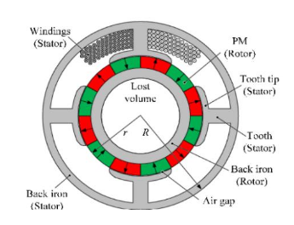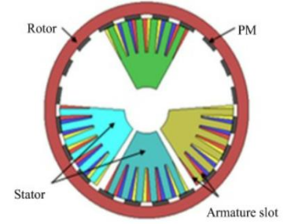

Figure 2‑ Cross-sectional diagrams of permanent magnet synchronous motors: (a) with interior permanent magnets (IPM) embedded within the rotor, and (b) with surface-mounted permanent magnets (SPM) attached to the rotor surface, showing key components such as stator windings, teeth, and armature slots. [11]

a) IPM synchronous motors

## Stator Assembly

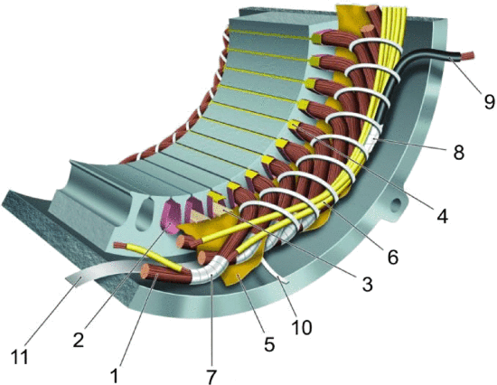

Figure 2‑: Overview of insulating and supporting parts in a low-voltage insulation system [6]

The stator core is built from laminated electrical steel sheets, cut via punching or laser processes. These laminations are then stacked and bonded through riveting, welding, or adhesive techniques, to form the magnetic core essential for motor function.The **motor housing** is typically produced using **pressure die-casting** and subsequently machined to ensure surface quality and dimensional precision. Figure 2-1 shows typical insulation elements in a stator, including 1 turn insulation, 2 slot liner, 3 slot separator,, 6 lead sleeving, 7 coil-nose tape, 8 connection tape, 9 cable, 10 tie cord, and 11 bracing [12]

Once the stator core is assembled, several key sub-processes follow. One of the first is the insertion of slot insulation to electrically isolate the windings from the core. This is followed by the winding process, in which copper wire is inserted into the stator slots. Depending on the motor design and production requirements different winding techniques may be employed, such as linear winding, needle winding, flyer winding, or the pull-in method using pre-formed coils. After winding, the wire ends are insulated, the winding head is formed, and the conductors are interconnected using methods such as crimping, soldering, or suitable welding techniques. The stator is then mechanically stabilized using bandaging and impregnated with resin through processes like trickling, dipping, or vacuum pressure impregnation, to enhance insulation and thermal dissipation. Electrical tests are carried out to verify winding resistance, insulation quality, and overall functionality [4].

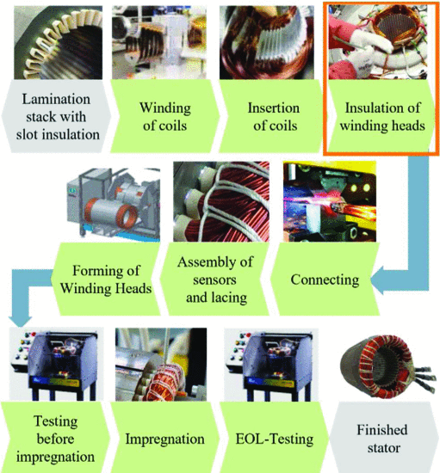

Figure 2‑: Production process of a stator with insertion winding [13]

Within the stator assembly process, one of the most crucial and delicate steps is the insertion of slot liners, as it directly influences both the electrical insulation and thermal performance of the machine. Given that this project focuses on automating this step using a robotic system, it is important to first consider the function and importance of slot liners in motor manufacturing.

## Slot liner function and Importance

One of the most critical and delicate steps in stator manufacturing is the **insertion of slot insulation**, often in the form of **slot liners**. These components serve two essential functions: they electrically isolate the stator windings from the core and contribute to **thermal management** by enabling heat dissipation from the windings. Especially in low-voltage electric motors, the slot liner must balance **high dielectric strength** with **thermal conductivity**. Material selection is therefore crucial, as improved thermal performance can directly enhance motor efficiency and longevity. [13]

In particular, the thermal management role of the slot liner is heavily influenced by how heat flows through the stator slot. Fig 2-7. illustrates the direction of the heat flow, which is from the middle of the slot to the laminate, passing through several layers of winding and the slot liner. A major challenge in this path is the interface air gap between the liner and the laminate, particularly at the rounded corners of the slot, where geometric mismatches increase thermal resistance. This interface gap acts as a thermal barrier, impeding effective heat dissipation. However, proper impregnation techniques can mitigate this issue by filling the gaps, thereby improving thermal contact and overall heat transfer. Consequently, key factors influencing slot thermal performance include the air gap at the liner-laminate interface, the thermal properties of the slot liner material, and the effectiveness of impregnation [14]

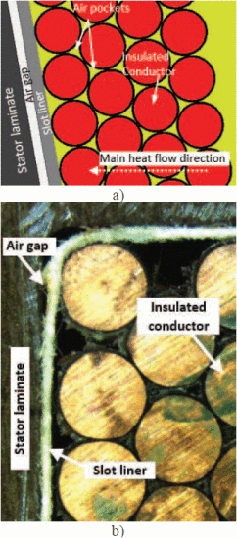

Figure 2‑: Stator slot in (a) detail model (motor-cad) and the (b) actual stator slot [8]

Given the high level of precision and repeatability required, manual insertion of slot liners is often inconsistent, time-consuming, and prone to errors that can compromise motor performance or even cause premature failure. This makes the automation of slot liner insertion not only attractive but also increasingly essential for modern manufacturing. Among the available automation solutions, robotic systems stand out due to their flexibility, accuracy, and adaptability to delicate handling tasks, making them particularly well-suited for slot liner insertion. The following section therefore examines robotic systems designed for insertion tasks and their relevance to this application.

# Robotic Systems for Insertion Tasks

In industrial automation, robots are programmable machines capable of executing a wide variety of tasks with high speed, precision, and repeatability. Their adoption has transformed manufacturing environments by automating repetitive or complex processes, thus enhancing productivity, improving safety, and ensuring consistent product quality. The flexibility of modern robots allows them to adapt to diverse product designs and fluctuating production volumes, which is particularly valuable in applications such as stator assembly, where tasks like slot liner and winding insertion demand both accuracy and adaptability. For tasks such as slot liner insertion, which require precision, repeatability, and delicate handling, certain robot types are more suitable than others.

## Suitable Robot Types

Modern industrial automation relies on a diverse array of robotic systems, each tailored to specific tasks and operational environments. Among the most prevalent are Articulated robots, SCARA robots, Cartesian and Delta robots. Articulated robots are described as robotic arms with multiple rotary joints, often resembling a human arm, which allows them to perform a wide range of movements and tasks such as welding, assembly, and material handling. Selective Compliance Assembly Robot Arm (SCARA) robots, characterized by three revolute and one prismatic degree of freedom, have become a mainstay in packaging and assembly line automation.These robots are now commercially availabe in a wide range of sizes, linear speeds, and payload capacities to suit diverse industrial needs. While their control systems are typically optimized for standard industrial operations, these configurations often lack the flexibility required for advanced research applications. Cartesian robots, also known as gantry robots, move linearly along three perpendicular X, Y and Z axes, and are commonly used in applications that require straight-line movements such as CNC machine operations and automated drawing or cutting. Delta robots are constructed with lightweight, parallel arms connected to a fixed base, enabling extremely fast and precise movements; they are especially suited for high-speed sorting and packaging tasks. Fig 3-1 illustrates the different robot configurations. [15–19]

Collaborative robots, or cobots, which are designed with advanced sensors and safety features to work alongside humans without the need for safety cages, are increasingly used for flexible automation in environments where human-robot collaboration is beneficial. Each robot type is engineered with specific kinematic structures and control systems, allowing them to excel in particular industrial roles and adapt to the evolving demands of modern manufacturing. In this project, a UR10e robot is utilized as the collaborative robot of choice. As a cobot, the UR10e offers several distinct advantages in flexible automation settings. Its advanced safety features, including integrated sensors and force-limiting technology, enable it to work safely alongside human operators without the need for traditional safety cages. This not only enhances workplace safety but also allows for more efficient use of floor space. Additionally, the UR10e is designed for ease of use, featuring an intuitive programming interface that enables quick setup and redeployment for a variety of tasks. Its flexibility and adaptability make it ideal for environments with evolving production requirements, while its ability to automate repetitive or ergonomically challenging tasks helps improve overall productivity. By integrating the UR10e cobot, the project benefits from increased efficiency, enhanced safety, and the ability to quickly adapt to changing manufacturing demands. The UR10e’s precision, flexibility, and safe operation are made possible by its advanced kinematic design and motion control systems. A clear understanding of these principles is essential for effectively programming and deploying the robot in delicate tasks such as slot liner insertion, as they govern how the robot moves, positions its end-effector, and executes trajectories with high accuracy. [20]

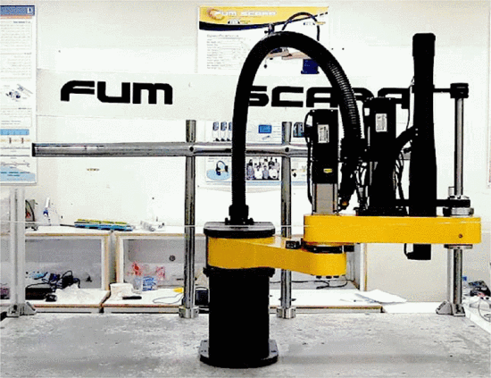

Fig.2-7 (a) SCARA Robot [23]

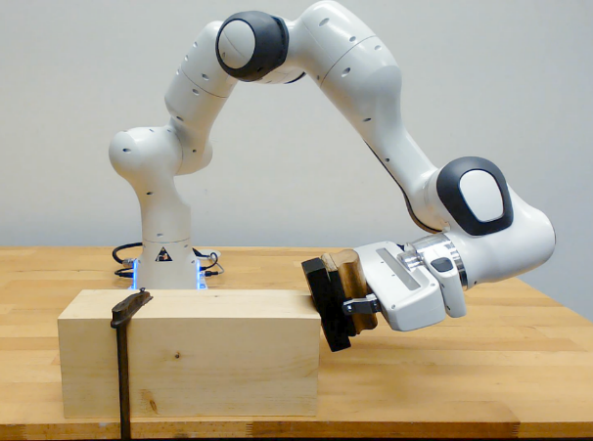

Fig 2-7 (b) Articulated robot [24]

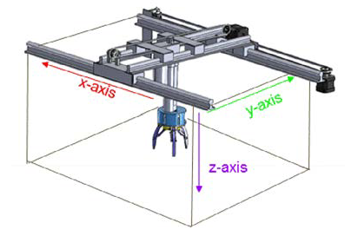

Fig 2-7 (c) Cartesian Robot [26]

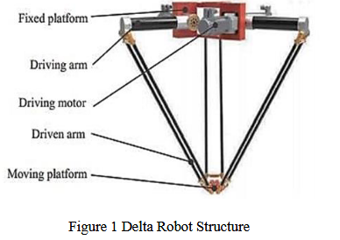

Fig 2-7 (d) Delta Robot [25]

Figure 3‑: Examples of common industrial robot configurations used in manufacturing and automation.

## Kinematics and Motion Control Principles

Kinematics and motion control are foundational to the operation and effectiveness of collaborative robots such as the UR10e. Kinematics refers to the mathematical and geometric study of a robot's movement, focusing on the relationship between joint parameters and the position and orientation of the end-effector, without regard to the forces involved. In the context of the UR10e and similar cobots, both forward and inverse kinematics are essential: forward kinematics calculate the end-effector's position from given joint angles, while inverse kinematics determine the necessary joint angles to reach a desired position and orientation in space. [21]

Building upon the understanding of forward and inverse kinematics, Universal Robots' UR10e utilizes the Denavit–Hartenberg (D-H) convention to systematically model each of its six revolute joints. This modeling framework enables the formulation of transformation matrices that map joint space coordinates to Cartesian space, which is crucial for precise motion planning and real-time control. The D-H parameters define the spatial relationship between links, allowing for calculated transitions between various positions and orientations required during collaborative tasks [22]. The calculation of DH parameters in a UR robot is illustrated in Fig 3-2.

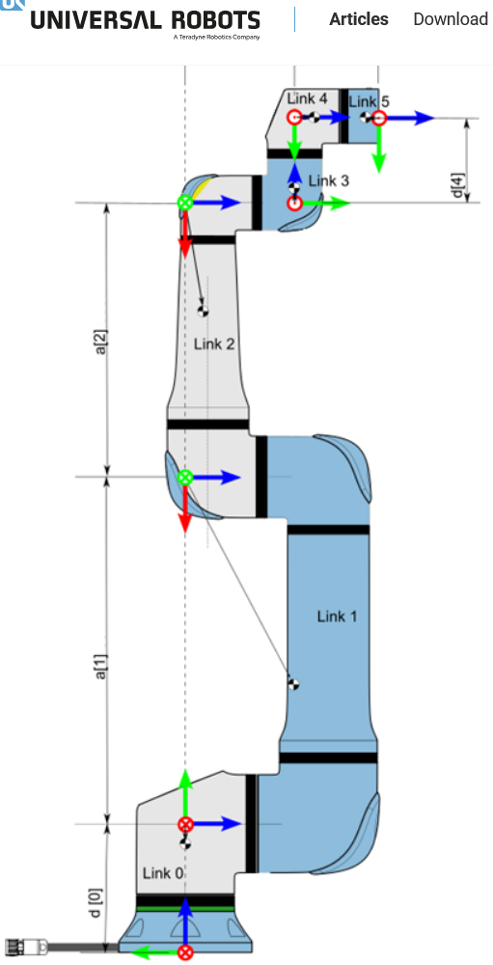

Figure ‑: DH parameter calculation in a Universal Robot [28]

Motion control in the UR10e combines these kinematic models with robust feedback mechanisms and trajectory planning algorithms. Typically, users command the robot via waypoints and trajectory definitions within the programming environment, with the robot’s low-level controller executing the appropriate joint movements to interpolate smoothly between points. The UR10e is fundamentally a position-controlled robot, its built-in controllers accept position and velocity setpoints, rather than torque commands, which means the system emphasizes accuracy and safety, making it well-suited for collaborative environments.The effectiveness of these kinematic and control principles is further enhanced by the UR10e’s modular design, extensive joint ranges, and safety features like collision detection and force limits. The combination of precise kinematic modeling and advanced motion control forms the foundation of the UR10e’s reliability, flexibility, and user-friendly operation in diverse collaborative applications. [23]. Although precise kinematics and motion control provide the foundation for accurate robot operation, achieving successful insertion of delicate components also requires an end effector designed to meet important requirements for accuracy, compliance, and adaptability.

## End Effector Requirements

The requirements for end effectors in robotic insertion tasks are shaped by the need for precision, adaptability, and safe handling of often delicate or varied components. For such tasks, the end effector must ensure positional accuracy and repeatability, minimizing insertion forces to protect both the components and the robot. Research highlights the importance of compliance, either through mechanical design or sensor feedback, to accommodate minor misalignments or uncertain tolerances, which is especially significant in operations like slot liner insertions for small-batch, high-variant manufacturing. The end effector design can thus incorporate passive compliance or active sensing (vision, tactile, and force/torque sensors) to enhance performance and reduce the risk of damage or failure during automated assembly. Additionally, modularity and flexibility are crucial: end effectors must often be quickly reconfigurable or compatible with a range of tools to support the diversity encountered in low-volume, customized production environments. Sensors integrated within or attached to the end effector should also support real-time monitoring and adaptive control, key factors in boosting insertion success rates and advancing automation reliability for sensitive handling tasks. [24, 25]

## Sensors and Actuators in Robotic Insertion Tasks

From the requirements described in the previous sections, flexibility and ease of configuration are crucial to meet the current state of the art in low volume, high variance production environments. The choice of actuator is crucial: industrial robots and Cobots are well suited for these tasks due to their inherent flexibility in terms of size and motion, their cost efficiency compared to specialized machines and their ability to work with standard end effectors such as grippers. This section provides an overview of the typical actuators and sensors used in robotic insertion tasks. It introduces various types of electric grippers suited for precision handling, discusses the role of actuators and compliant control, and explains the importance of sensor integration, especially force-torque sensors, for achieving consistent and reliable insertion. Safety and human-robot interaction considerations in such systems are also addressed.

### Electric Grippers for Precision Handling

Electric grippers are among the most versatile and widely adopted end effectors in modern robotics, especially valued for their ability to deliver precise, repeatable, and programmable manipulation of objects in automated tasks. These devices come in numerous configurations, each tailored to address the diverse requirements of precision handling and insertion processes encountered in industrial and collaborative environments. The most common type is the parallel jaw gripper which employs two jaws that move synchronously to grasp objects with consistent force control and high positional accuracy, making it ideal for handling components with uniform geometry such as circuit boards or machined parts. [26]

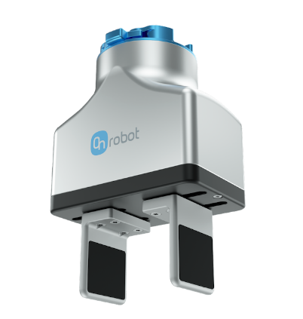

Fig 10 (a) Parallel jaw grippers

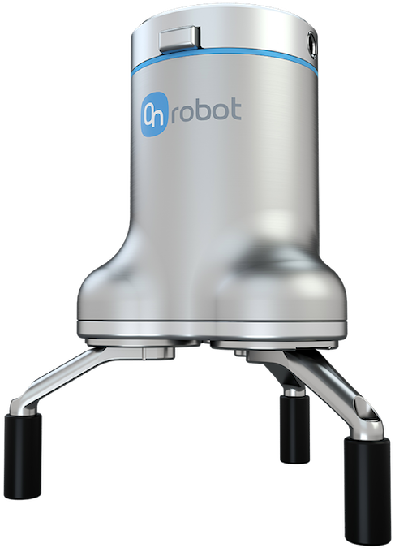

Fig 10 (b) Three Finger Grippers

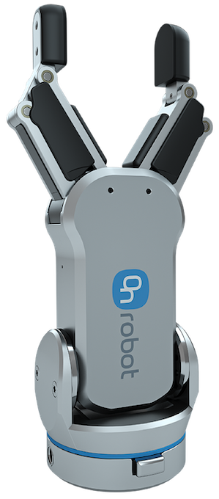

Fig 10 (a) RG2 Gripper

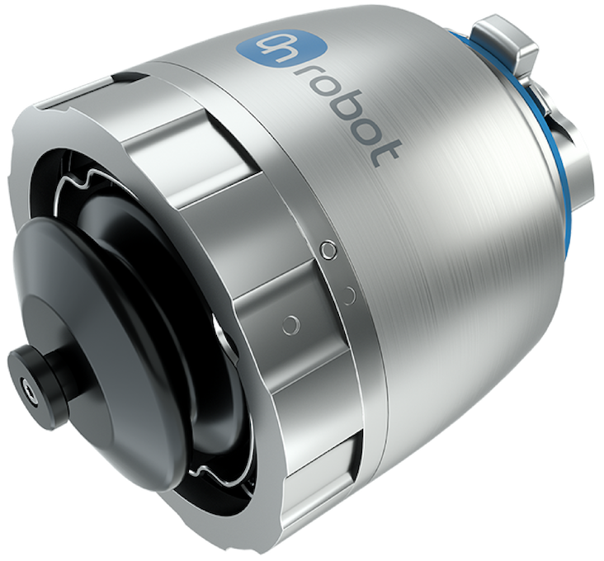

Fig 10 (c) Soft Electric Gripper

Figure 3‑: Different Gripper configurations provided by OnRobot [33]

Another prevalent design, the three-finger or centric gripper, uses a radial jaw arrangement to offer self-cantering and secure grasping of round or cylindrical items like pipes, bearings, or fasteners, ensuring stability during manipulation. Some electric grippers include built-in rotary axes, allowing them not only to grip but also rotate workpieces for orientation adjustments without additional arm movement, which improves operational efficiency in complex assemblies. For delicate or variably shaped parts, adaptive and soft electric grippers have emerged. These models use fingers with flexible or compliant material, sometimes powered by unique mechanisms such as tendon drives or shape-memory alloys to conform gently to irregular geometries, thus preventing damage during handling and adapting seamlessly to high-mix, low-volume production setups. Wide-stroke grippers extend this versatility further by accommodating larger or differently sized parts, supporting applications where component variability is high and downtime for changeover must be minimized. In collaborative workspaces, electric grippers designed for safety integrate features like force and speed limitation, smooth profiles, and compliance with international safety standards, allowing them to operate safely in proximity to human workers. [27–29]

### Role of Actuators in Precision Insertion Tasks

In robotic slot liner insertion, actuators form the backbone of all mechanical movements, enabling precise positioning, handling, and insertion of the slot liner into the stator slots. The robotic manipulator, such as the UR10e used in this project, relies on integrated servo actuators to achieve accurate, multi-axis motion. These actuators are responsible for carrying out trajectory planning, adjusting the insertion angle, and maintaining the correct force and speed during the operation. The end-effector equipped with an electric gripper, relies on fine motor control to grip and manipulate the slot liner without damaging or deforming it. This requires a delicate balance between firmness and compliance, especially due to the liner’s flexibility and the tight tolerances of the stator slots. [30]

However, achieving high precision in insertion tasks is not solely dependent on actuation. The presence of unexpected resistances, alignment mismatches, or minor positional deviations during real-world operation necessitates real-time feedback. To address these challenges, actuators must work in close coordination with sensor systems that monitor force, torque, and position. This interplay between actuators and sensors is especially critical in ensuring compliant control, a capability that allows the robot to respond adaptively to contact forces during insertion, reducing the risk of jamming or material damage. Thus, the effectiveness of the actuator system in slot liner insertion is greatly enhanced through integration with advanced sensing technologies, which are discussed in the following sections.

### Overview of Sensors in Automation

In modern automation systems, sensors serve as the fundamental building blocks of intelligence, acting as the eyes and ears of machines. They are responsible for capturing real-time data from the physical environment, which is essential for ensuring accuracy, repeatability, and adaptability in automated operations.They convert physical phenomena, such as measuring temperature in a furnace or detecting the position of a robotic arm, into electrical signals that can be interpreted by control systems such as PLCs or industrial computers.

By providing continuous feedback, sensors enable closed-loop control systems where real-time decisions can be made to adjust operations dynamically. This not only improves efficiency and safety but also allows for predictive maintenance and reduced downtime. As automation evolves towards greater complexity and autonomy, the demand for reliable, precise, and intelligent sensing technologies continues to grow. Depending on the specific application and the nature of the variable to be measured, a wide range of sensors are utilized in industrial environments. These can be broadly classified into categories based on the type of input they measure, such as proximity, pressure, temperature, force, or optical signals.

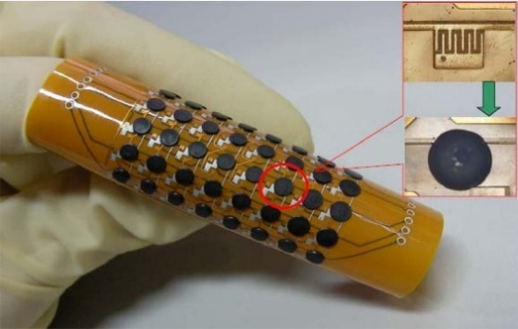

Fig 2-10 (a) Flexible Temperature sensors [38].

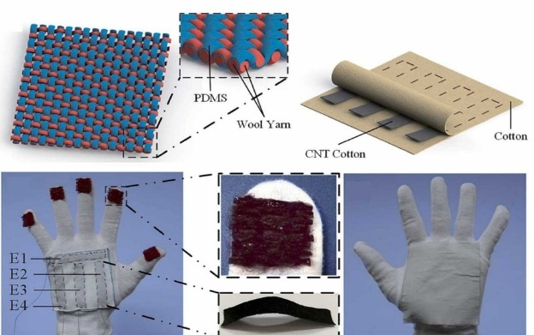

Fig 2-10 (b) Triboelectric flexible proximity sensor [40]

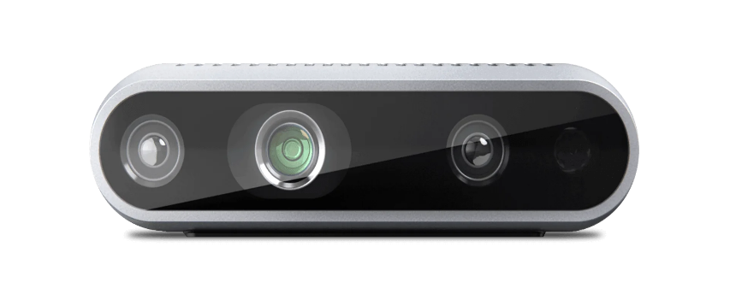

Fig 2-10 (c) Intel Realsense camera [39]

Figure ‑: Various sensors used in automation

In modern automation systems, a select range of sensor types forms the backbone of process monitoring and adaptive control. Temperature sensors, such as thermocouples and Resistance Temperature Detectors (RTDs), are widely deployed to maintain optimal operating conditions and safeguard equipment or product quality by continuously measuring and regulating process temperatures. Optical sensors use light to detect and measure changes in their environment, enabling fast and precise detection without physical contact. They are widely used in industrial automation for tasks like object detection, distance measurement, and quality control. An example of an advanced optical sensor system is the Intel RealSense camera illustrated in fig 11(c), which combines depth and visual imaging to provide detailed 3D data, supporting automated inspection and object recognition in modern manufacturing and robotics. [31–33]. Proximity sensors, including inductive and capacitive variants, enable non-contact detection of objects or machine components, forming the foundation for functions like robotic positioning, presence check in assembly lines, and operational safety interlocks.Triboelectric proximity sensors, Fig 11 (b), leverages the triboelectric effect to achieve self-powered, highly sensitive detection of nearby objects, expanding possibilities in applications such as smart robotics, gesture control, and wearable electronics [34]. Of particular interest in advanced robotic applications are force-torque sensors, typically mounted between a manipulator and its end-effector. These devices precisely measure the forces and torques experienced during manipulation or assembly, providing real-time feedback that allows robots to adapt to subtle variations, avoid excessive loads, and ensure gentle, accurate handling, especially important in tasks like delicate insertion processes. Together, these sensors deliver the critical feedback that enables high-quality, robust, and flexible automation, meeting the challenges of modern manufacturing’s growing need for adaptability and precision.

### Force-Torque Sensors for compliant control

Force-torque sensors are essential components in modern robotics and automation, enabling compliant control during a variety of tasks that require delicate manipulation, precision, and adaptability. These sensors are typically mounted between a robot’s manipulator and its end-effector, providing real-time measurements of both linear forces and rotational torques along multiple axes. Their primary function is to give robots the ability to “feel” their environment, much like the sense of touch in humans, by detecting even subtle contact forces during task execution. These sensors also facilitate compliant control, in which robots dynamically adjust their position and the amount of force applied, based on direct feedback from the environment. This ensures safe and adaptive interactions with objects or surfaces, reducing the risk of damage during tasks such as assembly, insertion, polishing, or when collaborating with humans. For example, during a precision insertion process like slot liner insertion, force-torque sensors enable the robot to sense misalignment and correct its approach in real time, minimizing insertion errors and ensuring gentle handling. [35]  
Technologically, most force-torque sensors rely on strain gauges or piezoelectric elements mounted on a compliant structure. As forces are applied, these elements deform slightly, producing electrical signals that are calibrated and interpreted by the robot’s controller. Sensors are manufactured to measure up to six degrees of freedom (three forces and three torques), which is essential for complex, contact-rich tasks in advanced manufacturing, automated assembly, and surface finishing. The integration of these sensors enables features such as rapid collision detection, skillful manipulation of fragile items, and enhanced safety when robots work alongside humans, as the sensors can trigger immediate corrective action in the presence of unexpected resistance or contact [36]. FT sensor mounted on a UR robot is illustrated in Fig 2-11.

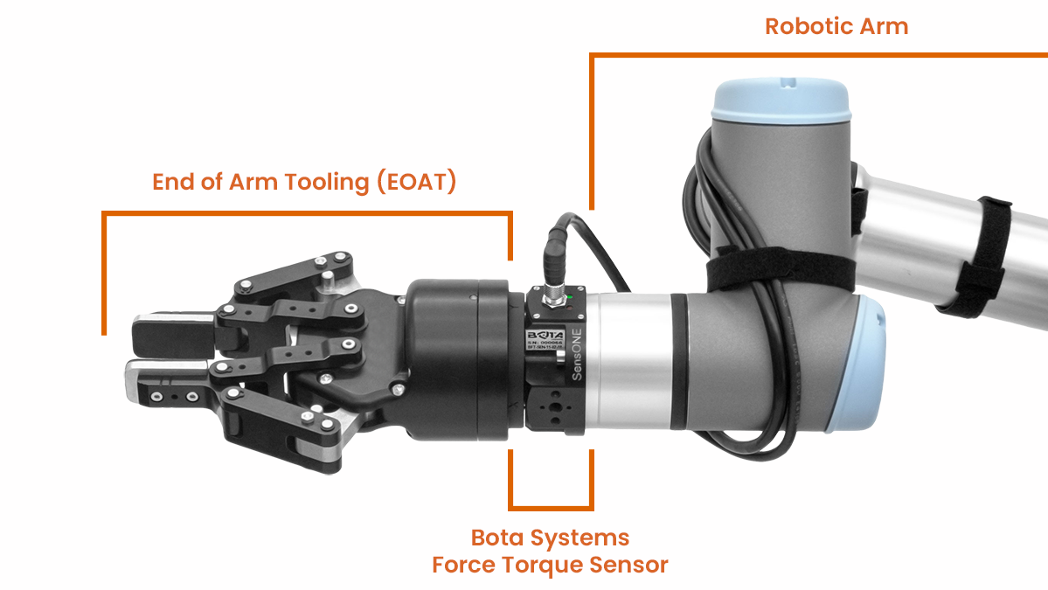

Figure ‑: Force Torque Sensor with gripper installed on a Robotic arm [42]

### Safety and Human Robot Interaction

As robotics and automation systems increasingly operate alongside human workers, the focus on safety and effective human-robot interaction (HRI) has become paramount. Safety in HRI aims to ensure that robots can collaborate with humans without posing risks, relying heavily on technological and regulatory frameworks. Robotic safety is achieved through the integration of advanced sensor technologies such as those mentioned in the previous sections, that allow robots to detect human presence, predict or monitor movement, and respond appropriately in real time. These sensors enable critical functionalities like workspace monitoring, adaptive speed and force control, and collision avoidance, thus preventing injuries and facilitating smooth cooperation. For example, modular sensing systems that combine tactile and proximity sensing have proven effective in both collision avoidance and cooperative guidance, allowing robots to adjust behavior dynamically depending on human actions. An example of a Human Robot Collaboration task is illustrated in Fig 2-12. [37, 38]

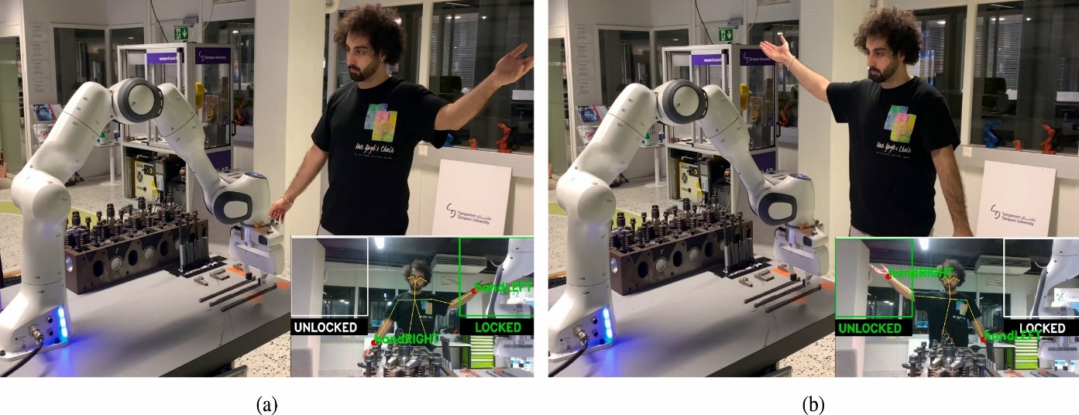

Figure ‑: : Results of human–robot collaboration experiments. (a) and (b) depict human task coordination by visual detection of the left wrist (handLeft), for halting the robot and performing manual assembly actions (a), followed by right wrist detection (handRight) [44]

International standards further enhance safety in collaborative workspaces. The ISO/TS 15066:2016 specification provides the key framework for designing and assessing the safety of collaborative robot systems. It sets requirements for the collaborative workspace, establishes maximum allowable levels of force and pressure for physical contact, and outlines robust risk assessment practices for various collaborative modes such as safety-rated monitored stop, hand guiding, speed and separation monitoring, and power and force limiting. Compliance with ISO/TS 15066 ensures that robots are designed and integrated with features that mitigate risks, thus supporting trustworthy human-robot collaboration [39].

With robust safety frameworks and advanced sensor integration laying the foundation for effective human-robot collaboration, the next critical element in modern automation is the method by which robots are programmed to perform their tasks. The choice of programming methods not only determines how robots interact with their environment and human coworkers but also directly influences their flexibility, intelligence, and ease of deployment within automated systems. The following section explores the various programming techniques used in robotic automation, highlighting how these approaches enable precise, adaptable, and efficient robot operation in increasingly complex industrial environments.

## Programming Methods in Robotic Automation

Programming methods play a pivotal role in defining how robots are configured, controlled, and optimized for various tasks within automation systems. As robotics technology has advanced, so too have the techniques used to instruct robots, which ranges from manually guided inputs to intelligent, adaptive programming environments. These methods serve as the foundation for enabling precision, consistency, and scalability in automated processes. The choice of programming approach can significantly impact system flexibility, integration effort, and overall efficiency. This section explores the key programming paradigms used in robotic automation and examines how they have evolved to meet the increasing demands of modern manufacturing, logistics, research, and service applications.

### Programming Using Teach Pendant and Manual Inputs

One of the most widely adopted methods for robot programming in industry is **online programming using a teach pendant**. In this approach, often referred to as the **lead-through method**, a skilled operator jogs the robot through the desired path using the pendant, recording specific waypoints that are later converted into motion commands. The operator is responsible for maintaining the robot's pose across all six degrees of freedom (DOF) during this process, which can be especially demanding when the task involves high precision or complex geometries.

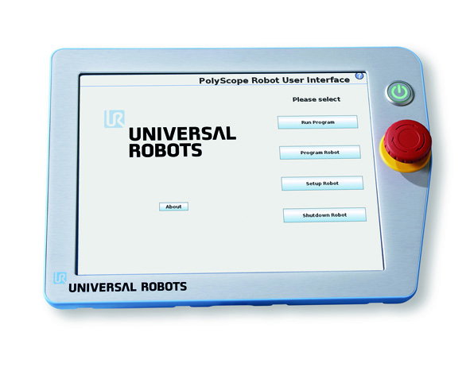

Figure ‑: UR Teach Pendant (Insert own image)

While the method offers the advantage of real-time feedback and does not require in-depth coding expertise, it comes with several **critical limitations**. First, the pendant interface is often unintuitive, multiple coordinate frames are defined within the robot system, requiring the operator to constantly track and select the appropriate reference frame. Furthermore, ensuring safe and accurate movements without causing collisions is both time-consuming and mentally taxing. Another significant drawback is the **lack of flexibility and reusability** in the generated robot programs. Even minor variations in the workpiece geometry can require complete reprogramming. Additionally, during the teaching phase, the robot cannot be used for production, reducing overall system efficiency. The quality of the motion paths also varies depending on the operator’s experience and skill level, leading to inconsistencies in task execution. Despite these challenges, this method remains the primary programming choice for small and medium-sized enterprises (SMEs) due to its lower upfront costs and the absence of a need for extensive software tools or external simulation environments. [40]

Teach pendants like Universal Robots' Polyscope not only allow for manual waypoint-based programming but also support the integration of custom script commands via URScript. This adds flexibility and allows for more complex behavior directly within the pendant interface. However, URScript is not limited to pendant use and it can also be executed remotely by sending commands from external applications over a network. This dual use makes URScript a bridge between traditional pendant-based methods and modern, fully automated robot control approaches.

### Implementation of UR Script

UR Script is the core scripting language used for Universal Robots, offering several modes of implementation to accommodate both simple and advanced automation tasks. Through the PolyScope teach pendant, operators can enter or insert URScript commands directly into the robot’s program. This allows blending graphical waypoint-driven teaching with text-based logic, making it possible to add conditional statements, loops, or sophisticated sequencing as needed. The pendant interface offers real-time feedback, program monitoring, and support for debugging, so users can refine URScript commands as they are developed. [41]

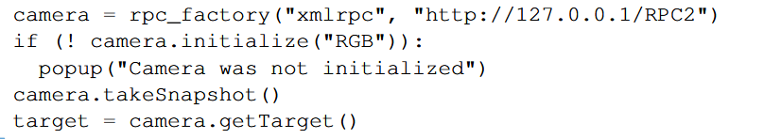

Figure ‑: Example of a URScript program to initialize a camera, take a snapshot and retrieve a new target pose [48]

For more integrated and flexible automation, URScript programs can be sent over a network using TCP/IP socket communication. This feature allows external computers, sensors, or higher-level controllers to transmit URScript code for execution, enabling real-time integration with vision systems, adaptive path generation, or manufacturing execution systems. The robot can open sockets, send and receive messages, and dynamically execute motion or I/O based on external data—widely used in advanced manufacturing and system integration. A typical URScript program initializes robot and tool parameters, defines input/output states, and specifies sequences of motion commands with instructions such as movej, movel, or movep. Programs often embed if- statements, loops, and interaction with external devices through I/O or network instructions. PolyScope-generated programs are always converted into URScript before the robot controller executes them, revealing how the script operates as the robot's fundamental control language [42]

The main advantages of URScript include increased programming flexibility, ease of reusing and modifying scripts, and compatibility with both manual and automated workflows. Scripts can be written, versioned, and transferred across different cells or tasks, supporting maintainability and scalability. However, using URScript does present a moderate learning curve, as it requires some familiarity with programming concepts and the robot’s API. Since URScript offers low-level control, scripts must be validated carefully to avoid unintended or unsafe robot behaviour. In summary, URScript bridges the gap between basic waypoint teaching and fully automated, networked robot control. It enables both incremental and transformative advances in factory automation, supporting the evolving needs of modern production environments.

### Programming using ROS

As automation tasks become more interconnected and dependent on external data sources, URScript alone may not offer the flexibility and scalability needed for full system integration. To address these broader requirements, the Robot Operating System (ROS) provides a comprehensive framework for modular robot software development, enabling seamless communication between heterogeneous nodes, external devices, and high-level control logic.

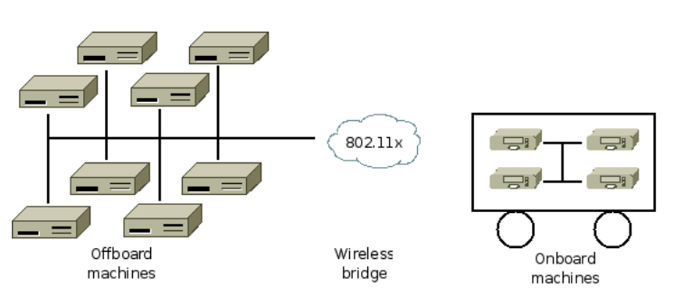

Figure ‑: A typical ROS network configuration [49]

The Robot Operating System (ROS) is a modular, open-source framework designed to simplify the development of complex robotic systems. Rather than functioning as a traditional operating system, ROS provides a flexible middleware layer that enables communication between distributed software components called “nodes”. These nodes interact using a publish-subscribe model via topics for asynchronous messaging or services for synchronous, request-response operations. This architecture promotes modularity and scalability, allowing systems to be assembled from loosely coupled parts that can be modified or replaced independently.

A key strength of ROS is its support for multiple programming languages, including C++, Python, and LISP. Communication between nodes is facilitated through a language-neutral interface definition language (IDL), which enables automatic generation of message-handling code in different languages. ROS encourages the use of standalone libraries for core functionality, keeping the system lightweight and components reusable. To support development, ROS provides a range of tools such as ‘rosbag’ for logging sensor data, ‘roslaunch’ for managing node networks, and ‘rviz’ for real-time visualization, all of which contribute to efficient testing and debugging.

Code in ROS is organized into packages, each containing nodes, configurations, libraries, and launch files. This structure supports collaborative development and version control, making it easy to manage large projects. ROS’s open-source nature and widespread community adoption have led to a vast ecosystem of packages for tasks like perception, control, and planning. By combining modular architecture with powerful development tools and cross-language compatibility, ROS serves as a foundational platform for integrating advanced robotics software in both research and industry. [43]

### Integration of Sensor Feedback

The integration of sensor feedback is fundamental to advancing robotic automation, allowing robots to transition from purely preprogrammed paths to adaptive, intelligent systems. While traditional methods like teach pendant programming and URScript provide a foundation for motion control, and frameworks such as ROS enable flexible software architectures, it is the real-time feedback from sensors that truly empowers robots to interact skillfully and safely with the environment. Sensor feedback bridges the gap between these programming methods by closing the loop between planning and execution, ensuring that robots respond effectively to changing process conditions or uncertainties in the work environment.

Modern robot systems leverage sensor feedback in several ways. On Universal Robots platforms, sensor data can be processed through URScript routines that adjust movement parameters or trigger safety responses when excessive force is detected. ROS further amplifies these capabilities by facilitating seamless integration of sensor data. Nodes within ROS can subscribe to force-torque sensor topics, process signals for filtering or calibration, and implement control algorithms such as force control or impedance control. This modular approach allows developers to combine real-time sensor feedback with higher-level logic such as path planning or AI-driven decision-making. The result is a system where the robot not only follows a taught trajectory but continuously corrects its actions to account for real-world variances and external inputs. In practical deployment, these technologies come together as follows: initial robot paths can be demonstrated and refined via the teach pendant, scripted for deterministic sequence execution using URScript, and further augmented through ROS-based sensor integration for adaptive, situational responses. Force-torque sensors play a central role here, enabling tasks that demand sensitivity or collaboration, such as precise insertion of Slot Liners in Stators, to be reliably automated. This holistic integration of programming interfaces and sensor feedback transforms modern robots into responsive, flexible, and safe collaborators in complex manufacturing settings. [44, 45]

Building on the latest advances in robotic programming, sensing, and automation, it becomes essential to translate these state-of-the-art methods into the actual physical setup required for real-world deployment. The following section focuses on the specific hardware components selected for this project, highlighting how each element has been chosen to meet the precise demands of automated slot liner insertion in electric motor stators.

# Methodology

The methodology for automating the slot liner insertion process in electric motor stator manufacturing was developed through a structured and iterative approach, combining practical observations, design iterations, and systematic validations. This section describes the research framework, details specific steps and strategies, and discusses the implementation of hardware and software systems supporting flexible automation.

## Research Approach and Iterative Process

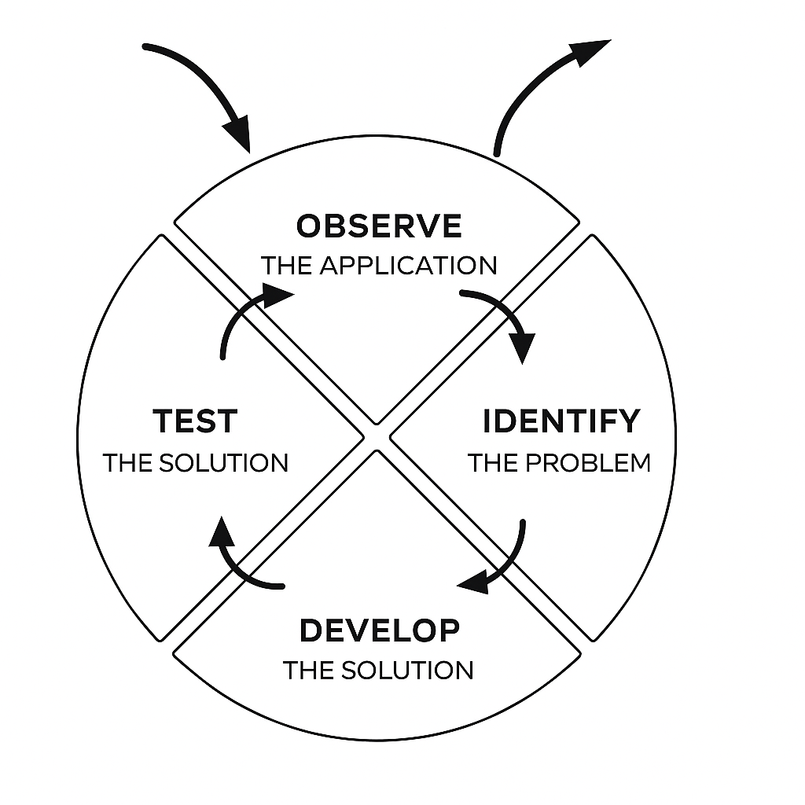

Figure ‑: Iterative research process

The research methodology for this project builds directly on the Iterative Research Pattern presented by Pratt [46]. The iterative research process involves a continuous cycle of four key steps. It begins with field observations, where researchers immerse themselves in the real-world application or environment to gather firsthand data and understand the domain. These observations serve as the foundation for generating relevant research questions and identifying practical needs. Next, the process moves to problem identification, where the observed data is analysed to pinpoint specific research problems or questions. Collaboration with domain experts helps refine and prioritize these problems, and after each iteration, test results are evaluated to identify new or evolving research challenges.

Following problem identification, the process advances to solution development, which involves creating prototypes, algorithms, or other technological responses tailored to the identified problems. Early stages may utilize simulations or mock-ups, while later stages focus on actual system development. The final step is field testing, where the developed solution is applied and evaluated in the original or a similar real-world setting. Feedback and observations gathered during testing inform the next cycle by refining the problem or introducing new questions. This iterative loop ensures a practical, evolving approach that grounds research in real-world needs and continuously enhances solutions through repeated cycles of observation, development, and evaluation.

## Observation, Challenges, and Development of Automation Approach for Slot Liner Insertion

Building on the iterative research process described above, this section applies the approach to analyze and improve the manual slot liner insertion task. The initial phase of the research involved a comprehensive collection and analysis of data related to manual slot liner insertion practices within small-scale motor manufacturing environments. This qualitative and observational study aimed to identify key challenges, sources of variability, and common errors encountered by operators during manual insertion. These insights shaped clear research objectives centered on increasing insertion accuracy, process repeatability, and flexible adaptation to diverse stator geometries and slot configurations.

With these problem definitions in hand, the project advanced into a development phase where the hardware components required for the insertion tasks were carefully selected, including the sensors, actuators, and the robotic platform necessary to enable automation. Building on this foundation, a parametric tool was developed to guide the slot liners accurately into varying stator slots. Rapid prototyping techniques such as CAD modeling and 3D printing facilitated swift iterations of the tool design. In parallel, robotic manipulation routines were implemented to carry out the delicate insertion tasks, incorporating precise gripping and force-feedback control. Key hardware elements, such as a motor-driven rotating clamp for accurate stator alignment and custom 3D-printed platforms for secure tool and liner positioning, were integrated to accommodate different stator sizes and optimize insertion angles. Each iteration was validated through field testing on representative stators, measuring success rates, error types, and cycle times. Feedback from testing closed the loop by confirming improvements or revealing new limitations, thereby prompting further refinement cycles. This iterative interplay between observation, problem-solving, and validation ensured that the automation solution remained closely aligned with practical manufacturing constraints and emerging insights.

## Testing Strategy and Evaluation Criteria

The testing strategy for validating the insertion tool centered on assessing its adaptability and reliability across three stators, each with different slot geometries and numbers of slots. The diversity was introduced to account for the practical variability in electric motor production and to maintain reliable performance under different conditions. The evaluation focused on systematic measurement of success rates, along with tracking and categorizing the types of errors encountered during the insertion process. Following initial trials, any observed defects or failures informed targeted optimizations to both the tool design and the insertion method. Iterative cycles of testing and refinement were conducted until a satisfactory and consistent success rate was achieved for all stator variants. This methodical approach helped ensure high accuracy and repeatability while verifying the tool’s suitability for flexible automated production.

The subsequent chapters translate this methodology into practice by addressing the specific challenges of slot liner insertion and developing a flexible automation solution. Drawing from the observations, problem analyses, and iterative development cycles described above, the work progresses through the design of automation principles, the integration of hardware modules, and the creation of a parametric tool and insertion pipeline. These implementations are then tested and validated on representative stators, demonstrating the effectiveness and adaptability of the proposed approach.

# Automation of Slot Liner insertion in Motor `Manufacturing

The process of inserting slot liners into stator slots varies widely across different manufacturing scales, from fully automated systems in mass production to manual operations in smaller workshops. This variation reflects the diverse requirements and constraints manufacturers face in balancing cost, flexibility, and quality. This chapter reviews various automation solutions and discusses the fundamental principles that guide their development and implementation in modern electric motor production.

## Common Challenges in the Insertion Process

While large-scale production of electric motors typically involves fully automated processes, it is not economically feasible to implement dedicated machinery for each stator variant in customized small-scale production. Consequently, slot insulation insertion is often performed manually, which introduces several challenges. Quality variations arise due to differences in operator skill and fatigue, leading to inconsistent placement of insulation materials that can compromise motor performance and reliability. Furthermore, the repetitive and physically demanding nature of this task increases the risk of physical strain and injuries among workers, especially when performed over extended periods. These factors, combined with high labor costs in many regions, result in a process that is not only expensive but also inefficient and prone to human error. [47]

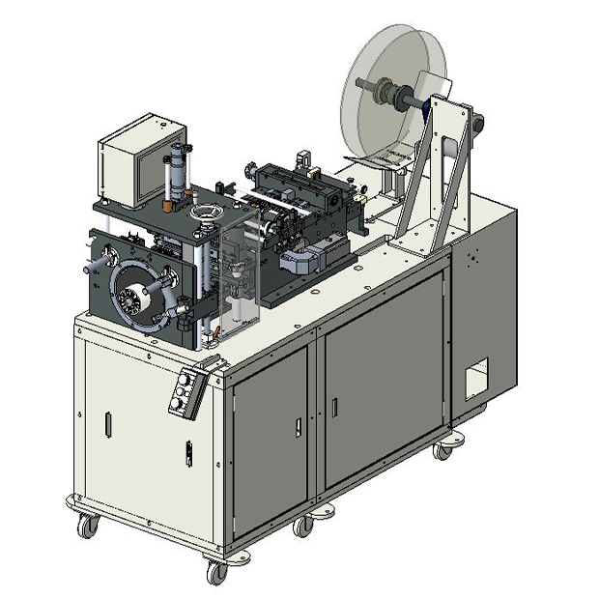

Figure ‑: GMW CS-5E Horizontal Slot Cell Inserter [49]

## Large Scale vs Small Scale Production Strategies

In the context of large-scale electric motor production, the slot liner insertion process is carried out using specialized automation systems designed for precision, speed, and adaptability. Slot insulation machines from manufacturers such as ELMOTEC STATOMAT, NIDE, and GMW are designed to automate and optimize this process for various stator designs. These machines, such as illustrated in Figure 5-1, insert specially shaped insulation paper into the stator slots using a coordinated sequence of creasing, folding, cutting, and inserting. The process guarantees precise alignment and paper overhang, which protects the copper windings from the sharp edges of the laminated core while maintaining a shape conducive to winding insertion. High-speed insertion rates, such as three sleeves per second, are achieved alongside consistent quality, even in small series production. Advanced features like servo-driven feeding, automatic paper forming, programmable interfaces, robotic loading/unloading, and computer-controlled moulds further enhance productivity and flexibility. The machines are engineered for durability, using tempered steel components and stable tubular frameworks, allowing for fast changeovers between stator types and reliable operation with minimal noise and user effort [48–50]. Despite the claimed applicability for smaller batch sizes, such systems are usually associated with high investment costs and optimized for repetitive, standardized processes. In high variance and low volume environments, frequent reconfigurations, longer set-up times and limited adaptability to manual or semi-automated downstream steps reduce their economic viability.

Despite significant advancements in automation, manual insertion of slot liners remains the standard practice in the small-scale manufacture of electric motors. In such setups, operators typically cut, fold, and insert the slot liners entirely by hand, or use machines for cutting and folding as shown in Fgure 5-2, while performing the insertion manually with simple jigs. This process relies heavily on visual inspection and tactile feedback to ensure proper alignment. Patent [51] supports this practice by describing slot liners designed specifically for manual or simple-tool-based insertion, featuring folded or cuffed ends, as illustrated in figure 3, to reinforce critical contact areas and prevent displacement during coil winding. Although effective for low-volume production, these manual methods are inherently limited in scalability. They are difficult to document for consistency and pose challenges for integration into modern digital workflows. As demand for electric motors continues to rise, this creates a growing incentive to explore scalable automation alternatives, not because manual techniques are flawed, but because they are labour-intensive, variable in quality, and harder to standardize across batches [12, 47, 52].

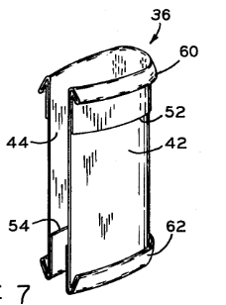

Figure ‑: : Folding of slot liner ends to reinforce critical contact areas [50]

Figure ‑: Adjustable grooving module with two gear-coupled rotating shafts [52]

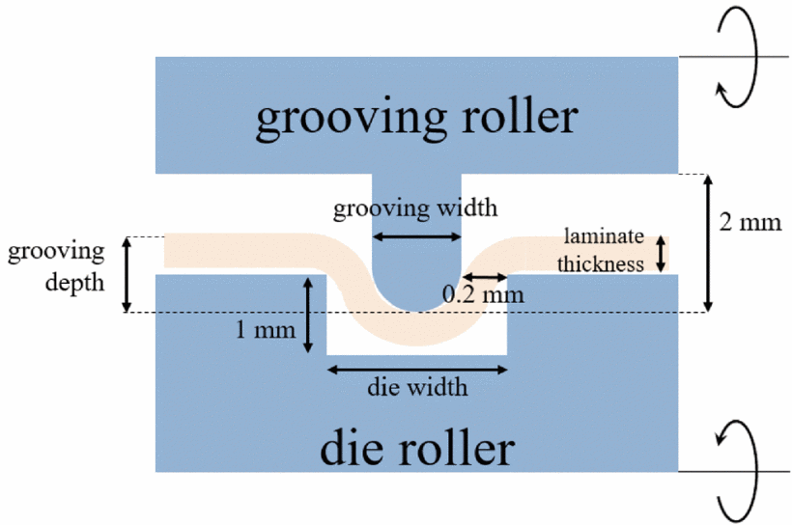

## Automation Principles

In modern manufacturing, especially for small batch sizes with a high number of variants, automation solutions must be both flexible and economical. A key principle is to transfer repetitive and physically demanding tasks from human operators to automated tools to improve consistency and reduce workload. To remain cost-effective in low-volume environments, such systems should allow easy configuration for new product variants, minimizing programming and set-up efforts. In addition, a modular system architecture-in both hardware and software-allows for incremental expansion and integration of advanced features, such as real-time process adjustments or data-driven optimizations. Stable processes form the basis for reliable production results, while scalability ensures that automation can grow with evolving production requirements. Together, these principles create a framework for the transition from purely manual assembly to flexible and economically sustainable automation in a high variety product field. [53]

### Design for flexible automation

Flexible automation in small batch production requires process designs that can efficiently accommodate frequent changes in product geometries and batch sizes. A key element in achieving this flexibility is parametric tool design, where CAD-based models are defined using parameterized design principles. This approach enables rapid adaptation to different shapes and sizes of stator slots with minimal lead times and low costs, so that tool changes do not become a bottleneck in production. Robots and standard end effectors further contribute to process flexibility, allowing automated systems to perform different tasks without extensive retooling. Modular system architectures create a foundation for future enhancements, such as vision feedback systems or sensor-based adaptations that can improve process reliability and adaptability in real time. Intelligent systems that use digital models, environment-specific knowledge and trajectory-based movement commands support stable and responsive adaptation to variable production scenarios. Finally, scalability remains a key aspect of flexible automation. Even with increasing batch sizes, modular upgrades and reconfigurable system components help to maintain efficiency and make production processes economical. [54]

### Variety in Stator Design for Slot Liner insertion

Electric motor stators exhibit a considerable variety of geometric and structural designs, driven by application-specific performance requirements and space constraints. Key variations include the stator diameter, axial length (stack length), the number of slots, and, crucially, the geometry of the slots and teeth themselves. The majority of stator designs used in low to medium power AC electrical motors feature a parallel-sided tooth, resulting in a trapezoidal slot profile. This configuration enables effective utilization of the stator core material and facilitates the accommodation of windings made from many stranded circular conductors, which can be efficiently fitted into the irregular slot profile. In contrast, an alternative approach, using a parallel-sided slot with a trapezoidal-shaped tooth, is more commonly found in larger distributed wound machines and aircraft generators. The specific configuration of stator slots and teeth has a significant impact on electromagnetic performance, including magnetic flux distribution, core losses, and winding arrangement. Optimizing these shapes is crucial for minimizing losses and improving the magnetic circuit, especially in high-speed or high-frequency applications.

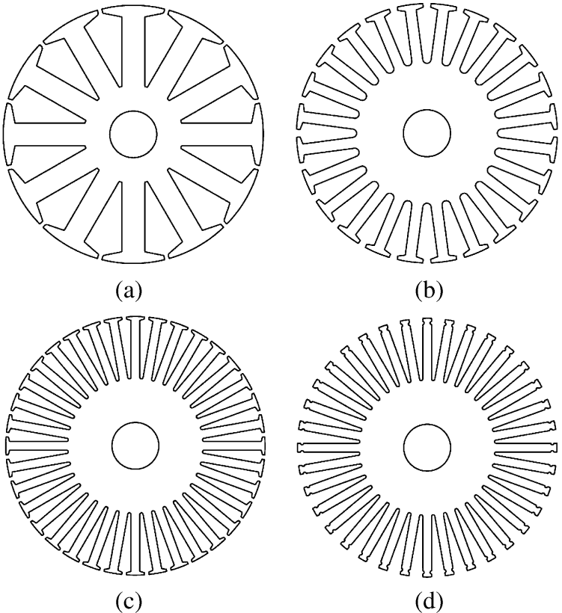

Figure ‑: Four typical stator configurations [20]

Furthermore, the choice of slot liner material and its thickness plays a vital role in electrical insulation and thermal management, though it may also affect the available slot area and winding fill factor. Modern design practices often rely on advanced simulation and modeling techniques to balance requirements such as efficiency, torque ripple, noise, and manufacturability, ensuring that the stator slot and tooth geometry is well-matched to the intended application and winding configuration [55, 56] . Different Topologies of the stator such as (a) 12 stator slots. (b) 24 stator slots.(c) 36 stator slots. (d) 36 open stator slots are shown in Fig 2-5.

In view of this wide range of geometries, this paper focuses specifically on medium-sized stators, which are often used in industrial applications and are equipped with U-shaped slot liners. This slot liner shape is widely used in these stators as it provides a reliable balance between mechanical protection of the windings and simple insertion processes. In addition to the U-shaped liners, other common forms of slot liners such as L-shaped configurations are also adapted to specific stator geometries and winding techniques. By focusing on this segment, a clear scope for the analysis and optimization of insertion techniques for slot liners is ensured, while at the same time taking into account the practical challenges of variant management in low-volume production. [57]

### Influence on Insertion tooling and strategies

The geometry of slot liners, particularly the distinction between U-shaped and L-shaped configurations, exerts a significant influence on both insertion tooling and assembly strategies in stator manufacturing. U-shaped liners are often favored for their ease of handling, as their single-piece design is compatible with standard insertion tools, allowing for straightforward and efficient placement into the stator slots. This simplicity supports both automated and manual insertion processes, making U-shaped liners especially suitable for medium-sized stators in industrial applications. In contrast, L-shaped liners, as showin in Fig 4-4 which are typically inserted in pairs to form a complete insulation barrier, may require more precise alignment and specialized tooling to ensure both halves are properly positioned and retained during coil insertion. The presence of features such as reinforced cuffs at the slot edges further affects tooling requirements, as these areas may need additional support or guiding mechanisms to prevent damage or displacement during high-force insertion processes. Moreover, the choice of liner material and thickness also impacts insertion strategies, with thicker or stiffer liners demanding more robust tooling and careful handling to avoid folding or snagging. Ultimately, the selection of slot liner geometry not only shapes the design of insertion tools but also dictates whether fully automated, semi-automated, or manual strategies are most appropriate, particularly in low-volume or highly customized production environments where flexibility and precision are significant. [57]

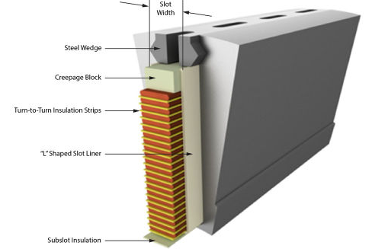

Figure ‑: Cutaway view of a stator slot showing the arrangement of insulation materials and components [21]

While existing approaches struggle to balance flexibility and efficiency, the methodology developed in this work demonstrates how collaborative robotics and parametric tools can address both. When equipped with the parametric tool, the robot system can perform slot insulation insertion for a variety of stator geometries without requiring extensive hardware changes for each variant. This enables a consistent and repeatable process, improving operational efficiency and providing the flexibility required in high-variety, low-volume production environments. At the same time, the system is designed to minimize programming effort and allow for quick reconfiguration between different stator types to ensure overall cost efficiency, especially in high labour cost environments. Potential application scenarios, advantages and limitations of robot-assisted automation solutions have been explored and discussed in previous research work, e.g. Kühl et al. [58], Mahr et al. [59] or Henrich et al. [60]

# Hardware setup for flexible slot liner insertion

The hardware setup is centered around a modular robotic cell designed to support flexible and precise stator production for electric motors. The stator is mounted vertically in a motor-driven clamp to enable accurate angular positioning of the slots. To support the insertion process, the system also includes dedicated platforms for positioning both the insertion tool and slot liner. Together, these components enable the efficient and smooth insertion of slot liners, forming a cohesive system tailored for reliable and high-precision operation.

To realize this integrated hardware setup, the system is structured into modular subsystems that address different aspects of the insertion task. The Robotic Module provides the core manipulation capability, combining motion control, force feedback, and adaptable gripping for handling slot liners and guiding tools. Complementing this, the Rotating Clamp ensures precise angular alignment of the stator, enabling sequential and automated liner placement across all slots. Finally, the Tool and Slot Liner Placement Platforms guarantee consistent and repeatable positioning of the auxiliary components required during each insertion cycle. In the following sections, each of these subsystems is described in detail, outlining their functionality, design rationale, and contribution to the reliable operation of the overall cell.

## Robotic Module

The Robotic Module consists of a Universal Robots UR10e Cobot, an OnRobot RG2 Gripper and a HEX Force-Torque (FT) sensor as shown in Fig.5-1, all coordinated through a central compute box that enables real-time control and adaptability. The Cobot provides programmable motion control, enabling repeatable execution of the insertion tasks. The FT-sensor is mounted on the wrist of the robot for measuring interaction forces during operation. The gripper is attached to the FT-sensor, which allows for secure and flexible handling of the slot liners and funnels of varying sizes and geometries. The robot in combination with the FT-sensor and gripper forms a versatile platform for implementing advanced control strategies, improving insertion accuracy, and handling different stator geometries, typically encountered in small-batch electric motor production.

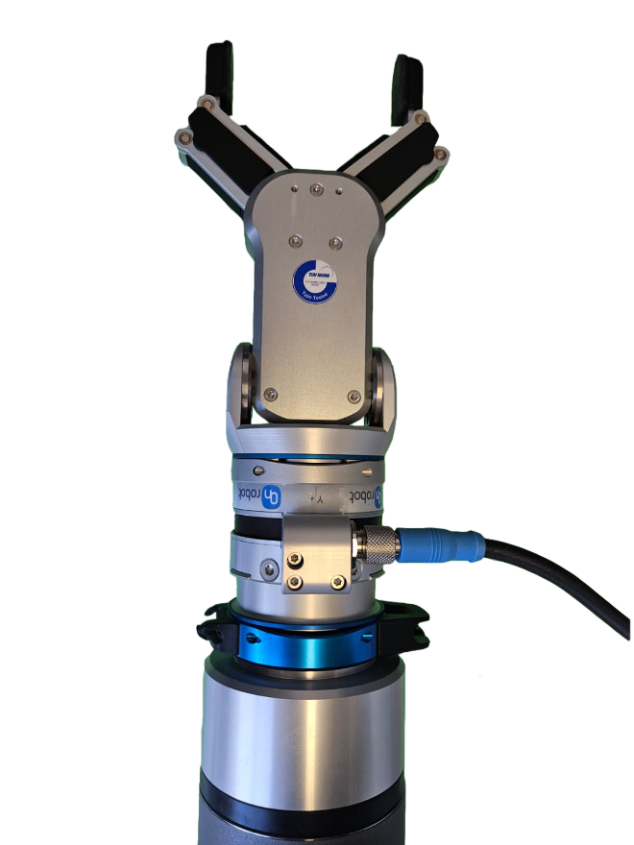

Figure ‑: OnRobot RG2 gripper with OnRobot HEX FT sensor mounted at the wrist, used for precise insertion and force monitoring

### UR10e Co-bot

In this project, a **UR10e collaborative robot** is employed as the primary robotic platform due to its versatility, safety, and adaptability in flexible automation settings. The UR10e incorporates advanced safety features such as integrated sensors, force-limiting technology, and compliance with ISO safety standards, enabling it to operate safely in close proximity to human workers without the need for traditional safety cages. This improves workplace safety while also reducing the overall footprint required for deployment, thereby optimizing floor space utilization. Ease of use is another defining characteristic of the UR10e. Its 12-inch touchscreen interface (PolyScope) and intuitive programming environment allow for rapid setup, redeployment, and task adjustments even for users with limited programming experience. These qualities make the UR10e particularly well suited for environments with changing production requirements, where it can be quickly reconfigured to perform new tasks. By automating repetitive or ergonomically challenging operations, it not only enhances productivity but also improves working conditions for human operators.

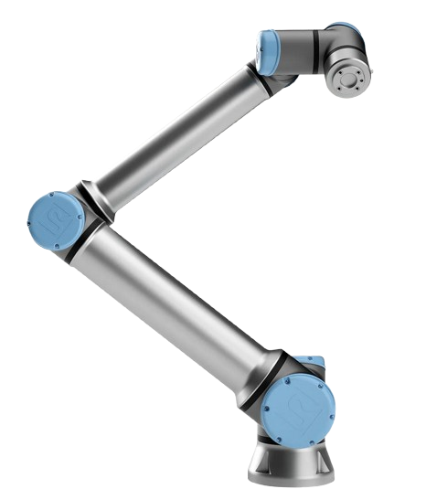

Figure ‑: Universal Robots UR10e collaborative robot featuring 6 degrees of freedom (6DOF) for flexible and precise movement, supporting a wide range of automation applications. [20]

From a performance perspective, the UR10e combines **strength, reach, and compactness** in a way that directly benefits tasks such as slot liner insertion. It supports a **payload capacity of 12.5 kg** and a **reach of 1300 mm**, allowing it to handle a wide range of components and end effectors while maintaining precision in both near and extended workspaces. Despite its long reach, the robot retains a compact design, with a **base footprint of only 190 mm** and a total weight of approximately **33.5 kg**, which simplifies installation and relocation in dynamic production layouts. The robot’s advanced kinematic design and motion control systems enable high accuracy and repeatability, while its integration into the **UR+ ecosystem** provides access to a broad selection of certified end-effectors, sensors, and software plugins that streamline customization and reduce integration risk. Taken together, these features ensure that the UR10e delivers precise, flexible, and reliable performance in automation scenarios, making it highly suitable for delicate, variable, and safety-critical tasks such as slot liner insertion in small-batch, high-variance manufacturing environments.[20]

### RG2 Gripper

The OnRobot RG2 gripper is a versatile, flexible two-finger collaborative robot gripper designed for a wide range of industrial applications. Featuring an adjustable stroke of up to 110 mm, the RG2 can automatically detect stroke size upon program start, enabling it to handle parts of various sizes and shapes with ease. Its plug-and-produce design simplifies deployment and reduces setup time, allowing quick integration into production workflows. The gripper includes intelligent features such as automatic tool center point calculation, payload estimation, depth compensation, and grip state detection, which minimize programming complexity and enhance reliability. For insertion tasks, the RG2’s precise and adaptable gripping capabilities enable secure handling of components like slot liners, while its customizable fingertips and force control allow careful manipulation to avoid damage. Its compatibility with collaborative robot systems and TÜV certification further support safe operation in shared human-robot environments, making the RG2 an effective tool for automating insertion processes with high flexibility and efficiency. [61]

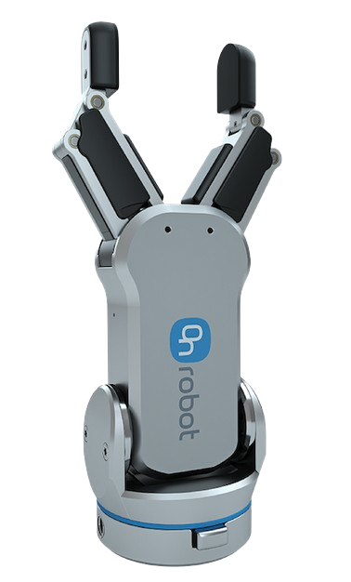

Figure ‑: The RG2 gripper, featuring intelligent automation functions and customizable fingertips for flexible part manipulation.

### HEX Force-Torque Sensor

Sensor-assisted modularity further enhances system performance through the integration of the OnRobot HEX 6-Axis Force/Torque Sensor, which accurately measures forces and torques along all six axes (Fx, Fy, Fz, Tx, Ty, Tz) in real time during the insertion process. This high-precision sensor provides valuable force-based feedback to ensure proper positioning and to avoid excessive forces or potential misalignment, significantly increasing the robustness and reliability of the system, particularly during the initial setup phase. Its unique optical-based technology offers robustness against shocks, while advanced force control maintains consistent speed and applied force throughout operations. Moreover, the integrated sensor opens possibilities for future developments, such as implementing closed-loop feedback control to refine insertion precision under varying mechanical tolerances. Easy installation, programming via an intuitive graphical interface, and compatibility with major robot brands make the HEX sensor an effective tool for enhancing dexterity and precision in complex and delicate manufacturing tasks. [62]

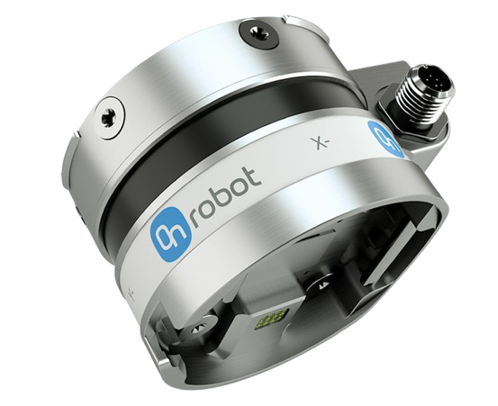

Figure ‑: OnRobot HEX 6-Axis Force/Torque Sensor measuring forces and torques along Fx, Fy, Fz, Tx, Ty, and Tz axes for precise robotic control.[60]

## Rotating Clamp for Stator Alignment

The stator itself was mounted on a mechanical rotary clamp that could rotate through an angle specified by the user. This rotary mechanism made it possible to adjust the stator incrementally so that each slot was aligned with the funnel after every successful insertion. The rotation step size was configured based on the number of slots in the stator, ensuring the system to perform fully automatic insertions across multiple slots without the need for manual repositioning.

To achieve precise alignment, the rotary clamp was driven by a servo motor under the control of a Siemens S7-1500 PLC, which executed low-level motion commands with deterministic reliability. A ROS-based middleware layer, running on a master PC, computed both relative and absolute rotation commands and communicated them to the PLC using the Snap7 library. Before operation, the clamp required manual calibration to a fixed hinge reference point, establishing a known origin for all subsequent movements. Once calibrated, relative rotation commands allowed incremental movement by a specified angle, while absolute rotation commands enabled the clamp to move directly to predefined angular positions, which is particularly useful in error recovery or when specific winding or insertion patterns are required. Additionally, a stop rotation function was implemented, enabling real-time interruption of the clamp’s movement to ensure safety, collision avoidance, and process adaptability. This combined ROS–PLC architecture provided the system with both robustness and flexibility, ensuring accurate, repeatable, and automated stator alignment during the insertion process

## Tool and Slot Liner Placement Platform

Customized 3D-printed platforms, as shown in Figure 5, were developed for secure and repeatable positioning of both the insertion tool and the slot liners. Each platform is precisely mounted on four robust aluminum profiles using nuts and bolts, providing a stable and rigid support structure that resists vibration and unintended movement during the automated insertion process. This solid mechanical foundation plays a vital role in maintaining the exact position and orientation of both the tool and slot liner platforms cycle after cycle, a requirement for reliable robotic operation. The modular design of these platforms allows for straightforward adjustments, enabling the rapid accommodation of different stator or slot liner geometries with minimal downtime. By leveraging parametric CAD models and 3D printing, new platform variants can be fabricated quickly and cost-effectively, supporting the dynamic needs of flexible stator production.

The funnel positioning platform is specifically engineered for the efficient and consistent placement of the insertion funnel, allowing the robot’s gripper to approach and grasp the tool without misalignment. Similarly, the slot liner platform holds a single, pre-folded slot liner in a fixed orientation, ensuring accurate and repeatable pickup by the robot. While manual reloading of these platforms is required after each insertion cycle, the precision and rigidity of the setup greatly enhance overall process repeatability and reduce alignment errors. This approach not only improves the consistency and stability of the insertion process but also enables a more efficient workflow in small-batch or high-mix manufacturing environments, where frequent product transitions demand both adaptability and reliability from the hardware setup.

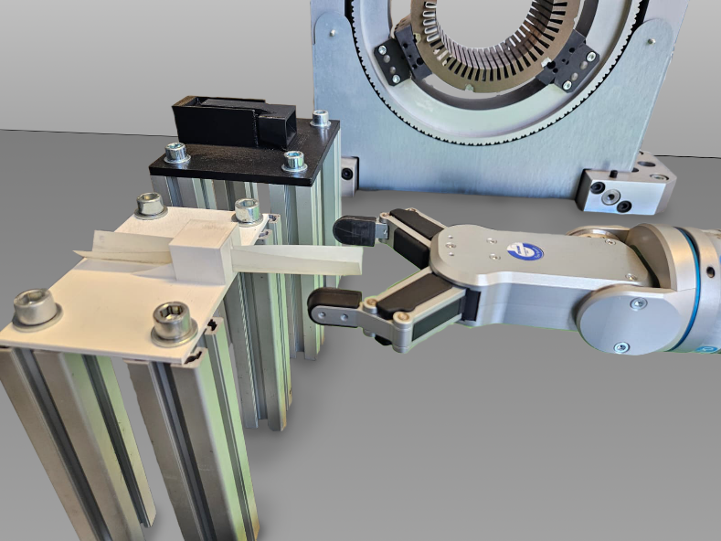

Figure ‑: Custom 3D-printed platforms mounted on aluminum profiles for precise positioning of the insertion funnel and pre-folded slot liner, enabling reliable and repeatable robotic gripping during the slot liner insertion process.

. The design principle of this tool, along with its various views, is presented in Figure 7-1.

# Parametric tool for flexible slot liner insertion

Although general design principles exist for stator slot configurations, the specific geometry is often customized to meet targeted performance requirements such as electromagnetic efficiency, torque output, thermal management and harmonic mitigation. As a result, slot dimensions and shapes can vary depending on the motor’s intended application [63]. For instance [64], reports stator slots with a height of 30 mm and a slot width of 20 mm, which employ relatively large slots.I n contrast, the stators used in this thesis follow a dimensional trend: smaller slots with gradually increasing slot counts from Stator A to C. Their exact specifications are introduced in chapter 9. This difference in scale is not trivial. Larger slots allow for easier handling and insertion of liners, while smaller and narrower slots demand greater precision during alignment and insertion, especially as the slot count increases. A higher number of slots also reduces the angular spacing between adjacent slots, amplifying the complexity of automated positioning and increasing the likelihood of liner deformation or misplacement. These factors highlight the practical challenges of developing a universally applicable insertion method.

Consequently, there is a clear need for adaptable tooling concepts that can accommodate such dimensional variations without requiring extensive manual reconfiguration. To address this problem, a parametric insertion funnel was developed as part of this study. The term parametric refers to the design strategy used: instead of creating a fixed funnel for each stator type, the model was designed so that key dimensions such as slot angle, slot width, and slot height can be adjusted by simply changing a few parameters. This reconfigurability allows the funnel to adapt to a wide range of stator geometries efficiently. The funnel thus serves as a guiding interface that aligns the slot liner with the stator slot, ensuring smooth insertion even under varying geometries

## Selection of Required adjustable parameters

The parameters selected for adjusting the funnel to specific stator configurations, as shown in Figure 6, are the slot width, slot height, and slot angle. These dimensions directly influence the geometry of the funnel and, consequently, the success of the slot liner insertion process. Slot height refers to the axial distance from the slot base (or root) to the slot opening at the stator bore, essentially defining how deep the insulation or winding material can be inserted. Precise matching of this parameter ensures that the slot liner reaches its intended seating position without deformation or buckling. Slot width describes the radial measurement across the slot opening, which sets the maximum allowable thickness for the liner and directly affects the clearance available during insertion. Accurate adjustment of this width prevents excessive friction while maintaining sufficient contact to keep the liner securely in place. The slot angle, on the other hand, represents the inclination of the slot walls relative to the radial axis and governs how smoothly the liner transitions from the funnel’s tapered channel into the slot. It also influences the degree of compression applied to the liner, ensuring that it is properly guided into position without being displaced or damaged.

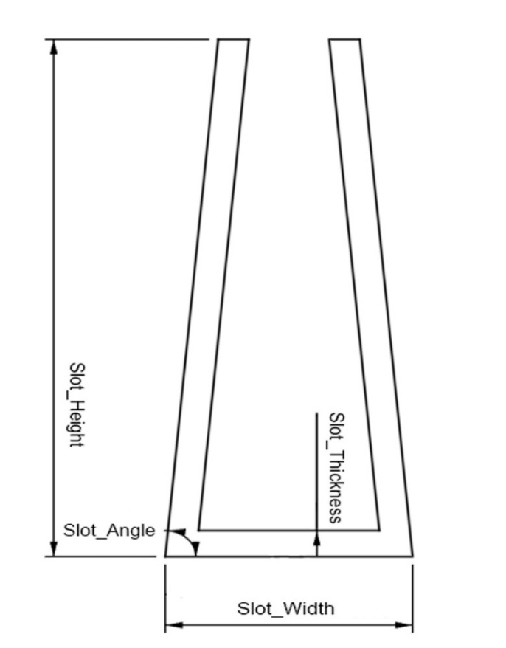Together, these three parameters form the foundation for a scalable and adaptable tool concept. By linking the funnel’s CAD model to the slot width, height, and angle, its geometry can be quickly and efficiently tailored to different stator designs without requiring a complete redesign of the tool. This parametric adaptability ensures reliable insulation placement across a variety of stator topologies, while also supporting repeatability and precision in robotic insertion. In the context of automated production, such flexibility is essential: it reduces setup time, minimizes error, and enables the system to handle diverse configurations with minimal manual intervention. As a result, the funnel design not only provides a robust insertion aid but also enhances the overall efficiency and reliability of the automation pipeline.

Figure ‑: Key parameters of the funnel design, including slot width, slot height, slot angle, and slot thickness

## Fundamental Tool design

The slot liner insertion tool is fundamentally conceived as a funnel-shaped guide positioned between the stator and the robotic gripper. Its primary function is to provide a mechanically defined path that simplifies the insertion task. The tool features a wide inlet that allows the slot liner to be introduced easily, while a progressively narrowing outlet channels the liner towards the stator slot. This geometric principle ensures that the liner is aligned and directed with minimal risk of twisting or misplacement during insertion. Beyond merely guiding the liner, the funnel concept addresses key challenges in robotic automation. It reduces the need for highly complex gripping strategies, tolerates slight deviations in positioning, and maintains smooth motion throughout the process. By acting as an intermediary between the robot and the stator, the tool enhances process stability while keeping the design straightforward and adaptable. These general principles form the foundation of the tool’s design, upon which more detailed functional features and refinements have been developed, as described in the following sections.

### Initial Tool model and design considerations.

Figure ‑: Initial tool design concept

a) Front view

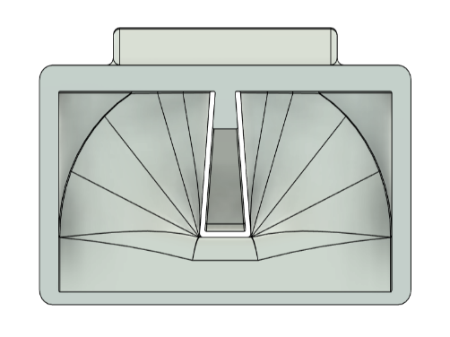

b) Rear view

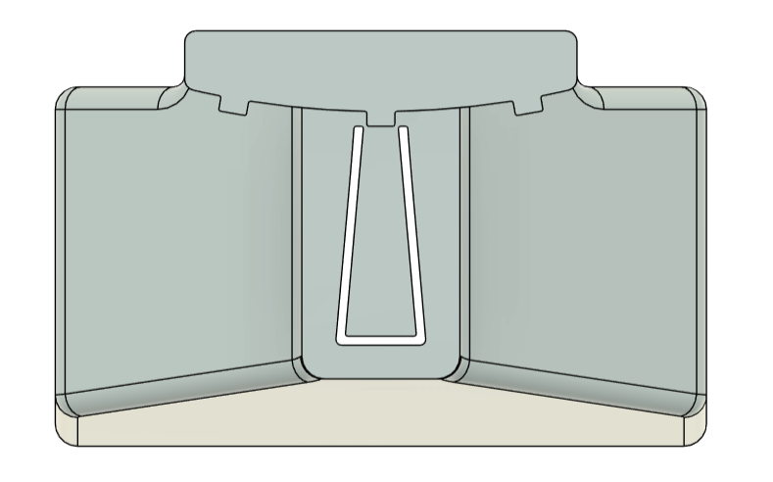

c) Side view

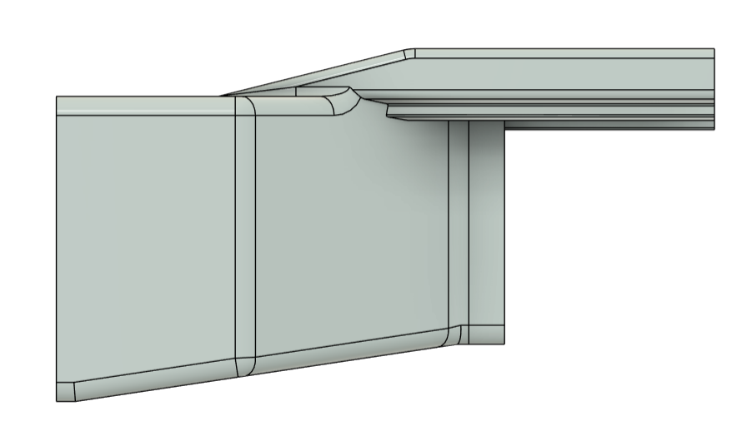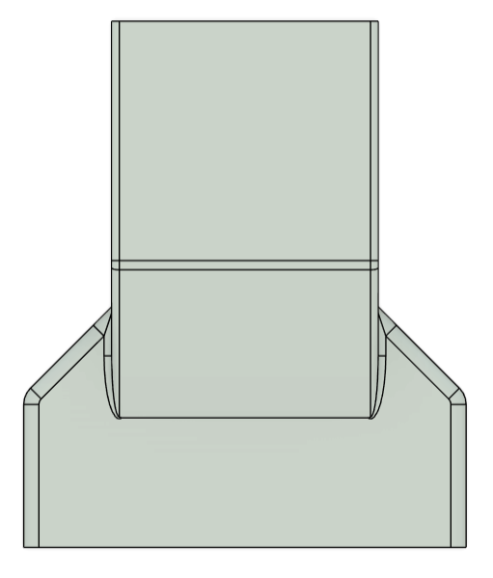

d) Top view

The funnel body has a flared geometry with an internal tapered channel that converges smoothly towards the stator slot, creating a well-defined path for the slot liner. The inner surface incorporates two gently curved guiding walls, which gradually redirect the liner towards the centerline of the tool. This curvature not only assists in achieving the correct slot position but also prevents abrupt changes in motion, reducing the likelihood of buckling or uncontrolled bending of the liner during insertion. At the core of the design is a central opening that forms the primary passage for the liner, ensuring a stable orientation and effectively preventing twisting as it moves through the channel. Along the insertion path, the taper is designed to apply a slight but uniform compression to the liner. This controlled compression helps the liner maintain its shape, increases its structural rigidity during handling, and improves positioning accuracy as it enters the stator slot.

To guarantee vertical alignment at the point of entry, the front face of the funnel integrates an inner guide rail, as shown in Figure 7-3, that extends directly towards the stator’s slot profile. This feature acts as a reference edge that constrains the vertical position of the liner and guides it along the exact geometry of the stator slot. By doing so, it establishes a repeatable insertion height and ensures that each cycle produces consistent results, even in automated operation. The ends of the guide rail are intentionally tapered, a detail that minimizes the possibility of the slot liner catching or being pulled back together with the funnel during retraction. This not only facilitates smoother disengagement but also enhances process reliability during repetitive robotic handling.

The rear of the tool features three external guiderails, that play a crucial role in maintaining alignment between the funnel and the stator during both setup and operation ( Figure 7-4). These external rails act as stabilizing features that engage with the stator surface and effectively prevent unwanted lateral shifts of the funnel. By defining fixed points of contact, they ensure that the funnel remains parallel to the stator face throughout the insertion process. This geometric constraint is essential because even small angular deviations could cause the funnel outlet to misalign with the slot, leading to jamming or improper placement of the liner. The presence of three rails, provides a mechanically stable support structure that distributes contact forces evenly and eliminates wobbling during handling. During insertion, the guide rails function as reference surfaces that continuously regulate the orientation of the funnel, so that the internal tapered channel stays aligned with the stator slots. This guarantees that the insertion process proceeds smoothly, reduces the dependency on highly precise robot positioning, and minimizes the likelihood of cumulative alignment errors during repetitive cycles.

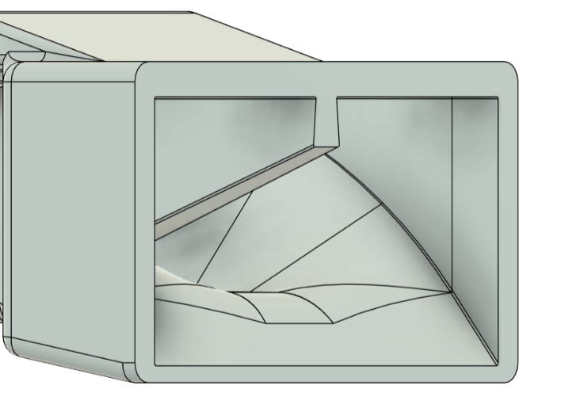

Inner guiderail

Figure ‑: Inner guiderail for vertical alignment

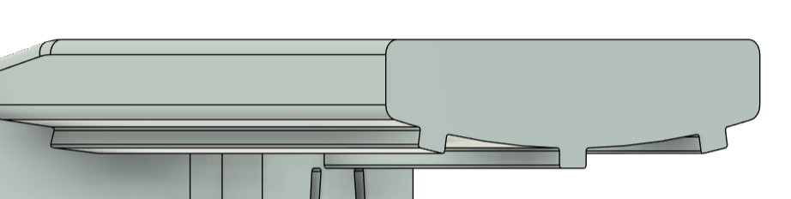

Figure ‑: Three external guide rails for proper alignment

The funnel inlet is deliberately widened to introduce a tolerance margin, allowing it to absorb minor positional deviations caused by robotic handling, operator setup, or dimensional variations in the stator itself. In practical terms, this means that the process is less sensitive to the absolute positioning accuracy of the robot, as small offsets are corrected by the inlet geometry rather than being transferred as misalignment to the slot liner. This not only reduces the complexity of the gripping and placement strategy but also enhances process robustness, ensuring smooth liner guidance under real-world operating conditions. For the initial model, the funnel slot height, width and angle were the same as that of the stator slot dimensions**.** To extend its usability across multiple stator variants, the inlet dimensions are parametrically linked to the slot height, such that any change in slot geometry automatically adjusts the inlet size in proportion. This parametric approach eliminates the need for manual redesign when adapting the tool to new stator configurations, streamlines the design workflow, and ensures that the guiding profile remains optimal for different slot dimensions. As a result, insertion reliability is preserved across a range of applications, while setup time and redesign effort are significantly reduced. Together, these features make the funnel both tolerant to misalignments and scalable across various stator types, offering a robust and adaptable solution for automated slot liner insertion.

The funnel is lightweight and manufactured through 3D printing using Poly Lactic Acid (PLA), a material selected for its balance of strength, dimensional stability, and ease of prototyping. PLA allows rapid design iterations at low cost, enabling quick adjustments to tool geometry during the development phase while still providing sufficient mechanical rigidity for repeated handling. A single funnel prototype required approximately 3 hours and 20 minutes of printing time, demonstrating that design modifications can be implemented and tested within the same working day, which is highly advantageous for iterative development. The side faces of the funnel are designed with flat surfaces to ensure compatibility with a variety of parallel-jaw robotic grippers, thereby reducing the risk of slippage and guaranteeing a repeatable grasping point. Furthermore, a 1 mm clearance is incorporated between the lower outlet of the funnel and the termination of the inner guide rail. This small but critical gap prevents mechanical interference during the transition from funnel to slot, compensates for minor dimensional tolerances in both the slot liner and stator geometry, and ensures that insertion proceeds smoothly without jamming. Together, these considerations make the tool both robust for automated handling and flexible enough to support consistent, reliable liner placement across multiple operating cycles.

During testing, the initial prototype demonstrated the feasibility of using a parametric funnel for automated slot liner insertion, but several design shortcomings became evident. These issues affected both the handling stability and the consistency of liner placement, revealing critical areas where further refinement was necessary. A detailed discussion of these flaws, along with the insights gained from their evaluation, is presented in the following section.

### Observations and Limitations of the Initial Prototype

Although the initial prototype validated the concept of a parametric funnel, several shortcomings were observed during testing that limited its robustness in practice. The most critical difficulty arose during the insertion of the funnel into the stator. The three external guide rails, while designed to improve alignment and seating stability, made the insertion step highly sensitive to angular deviations. If the robot approached the stator even a few degrees off-axis, the funnel would not fit correctly, making the process unreliable. Furthermore, the guide rails themselves were too shallow to provide effective retention. Although they contributed to positioning the funnel against the stator face, they did not lock it in place securely, which meant the tool could shift or disengage under certain conditions. This highlighted a structural weakness in the design, as the funnel was stable only after careful placement but not inherently self-centering or self-retaining.

A second set of limitations was linked to the funnel’s geometry and weight distribution. The outlet was designed with the exact profile of the stator slot, which caused interference during operation. Minor positional deviations frequently led to the funnel edges colliding with the stator slot opening, bending or tearing the ends and reducing both durability and insertion consistency. In addition, the tail section of the funnel was too short, leaving the center of gravity shifted forward. This imbalance made the funnel prone to tilting or even falling away from the stator, particularly during retraction movements of the robot. Together, these issues underscored the need for a revised geometry that not only improves insertion tolerance but also integrates a more effective locking strategy to secure the funnel during operation. While the prototype demonstrated the feasibility of guided liner insertion, these limitations made clear that refinement was essential for achieving reliable and repeatable performance in automated production.

The evaluation of the initial prototype highlighted the critical factors that limited its effectiveness, particularly with respect to insertion tolerance, stability, and durability. These findings provided valuable feedback for the design process and formed the foundation for targeted improvements. By addressing the identified shortcomings, such as the insufficient locking mechanism, shallow guide rails, fragile outlet geometry, and imbalanced weight distribution, the tool concept was refined into a more robust and production-ready solution. The resulting design, referred to here as the final tool, incorporates these enhancements to achieve reliable performance under automated conditions. The details of this optimized configuration are presented in the following section.

## Final design

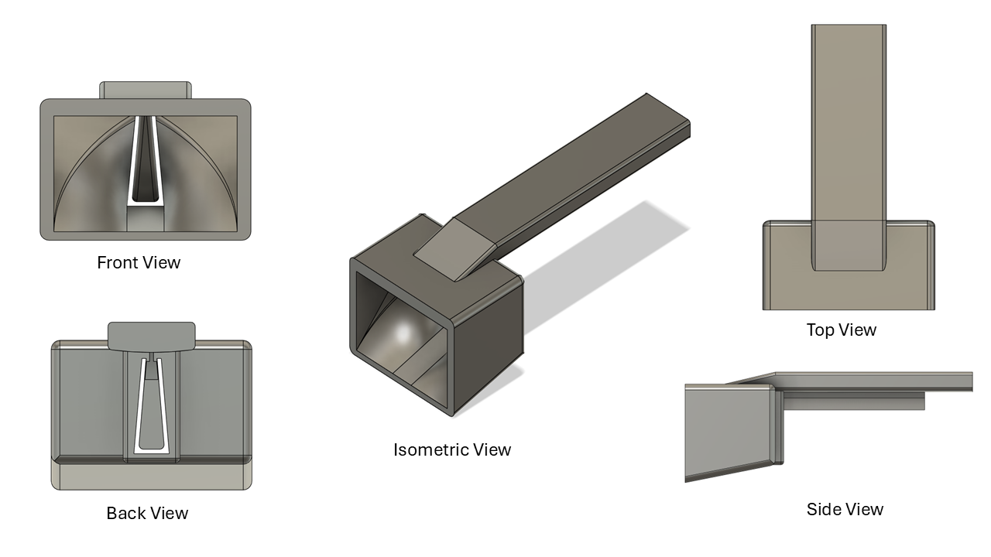

Figure ‑: Different views of the parametric funnel.

Building on the insights gained from the evaluation of the initial prototype, the final design of the parametric funnel incorporates several targeted optimizations to improve stability, alignment, and robustness during automated operation. One of the most significant modifications was the simplification of the external guiding system. Instead of relying on three guide rails, which had previously made insertion overly sensitive to angular deviations, the final version employs a single, elongated guide rail. This change significantly reduces the complexity of the insertion step, as the funnel’s seating is now dependent on only one reference feature, allowing smoother engagement with the stator face. To compensate for the potential loss of stability associated with reducing the number of rails, the guide rail was extended in length and fitted with grooves (Fig. 1). These grooves provide a mechanical locking effect that secures the funnel to the stator slot, preventing unwanted lateral shifts or accidental disengagement during handling. As a result, the tool achieves a balance between ease of insertion and positional stability, ensuring reliable seating without requiring ex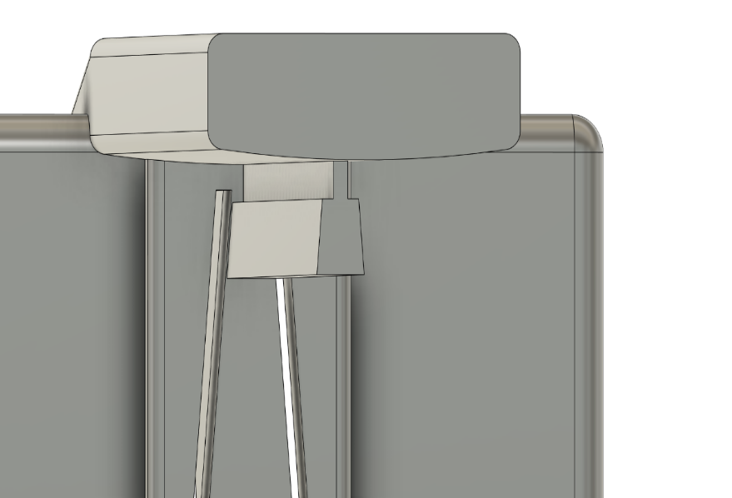tremely precise robot alignment.

Figure ‑: Grooves on the back of the funnel for proper alignment and locking to the stator slot.

In addition to the revised guide system, several structural refinements were introduced to enhance the overall balance and usability of the tool. The tail of the funnel was made both thicker and longer, with the rear section extended by 50 mm. This design choice intentionally shifts the center of gravity rearward, counteracting the forward tilting moments observed in the prototype and minimizing the likelihood of the funnel slipping away from the stator during robotic manipulation. The side faces of the funnel were redesigned with a more rectangular profile, providing a more secure gripping surface for parallel-jaw grippers and further improving handling repeatability. At the outlet, the geometry was modified to be slightly undersized—approximately 2–3% smaller than the actual slot dimensions. This adjustment ensures that the slot liner is guided into the stator smoothly, reducing the risk of its leading edge catching or being damaged against sharp slot boundaries at the start of insertion. Finally, the overall geometry of the funnel was simplified to better support its parametric adaptability. By keeping the structural features straightforward, adjustments to slot width, height, or angle can be made quickly in CAD without introducing unnecessary complexity or compromising manufacturability. Together, these refinements yield a more stable, reliable, and scalable solution, marking a clear improvement over the initial prototype and rendering the funnel suitable for repeatable use in automated slot liner insertion.

## A close-up of a metal corner AI-generated content may be incorrect.A grey rectangular object with a white background AI-generated content may be incorrect.Fitting Adjustable Parameters for Specific Use Cases

Figure ‑: Side by side comparision of old and new design

To validate the adaptability of the parametric funnel design, three stators with differing slot geometries were selected as representative use cases. The idea behind this selection was to test whether a single parametric model could be adjusted to accommodate varying geometrical requirements without the need for a complete redesign for each case. The funnel geometry was modified in CAD by tuning predefined parameters, particularly the slot height and slot angle, which are the two most critical dimensions influencing insertion behavior. In all three cases, the funnel slot height was intentionally set to be slightly lower than the actual stator slot height, providing clearance to minimize interference and prevent the risk of jamming during insertion. For instance, the funnel slot height was parameterized to 19.70 mm for the first stator, 21.70 mm for the second, and 17.70 mm for the third. This offset ensured that the funnel maintained guiding capability while enabling smoother liner placement, reflecting a balance between precision and practicality in the design approach.

Once the parametric adjustments were finalized, the customized funnels were fabricated using 3D printing, offering a rapid and cost-effective method for producing prototypes that could be directly tested. Following minor post-processing steps, the funnels were mounted and integrated with the robotic insertion system to allow functional evaluation under automated conditions. The validation experiments focused on two main criteria: the repeatability of the insertion process, measured by the system’s ability to consistently perform multiple insertions without misfeeds or failures, and the alignment accuracy, evaluated by how precisely the liners were guided into the stator slots. Testing across three stators with distinct geometries demonstrated the versatility of the parametric approach, showing that targeted parameter adjustments were sufficient to generate functional funnel variants for each case. The results confirmed that a single parametric model can be adapted to different stator designs with minimal effort, significantly reducing the redesign cycle and validating the feasibility of a flexible tooling concept for automated slot liner insertion.

With the final funnel design validated across multiple stator geometries, the focus could shift from the tool itself to the broader insertion workflow. The funnel represented only one element of the overall process, and its successful implementation created the foundation for developing a complete parametric insertion pipeline. This next stage integrated the funnel with robotic handling, sensor feedback, and modular control strategies, aiming to achieve a reliable and flexible solution for slot liner insertion in small-batch motor production.

# PARAMETRIC SLOT LINER INSERTION PIPELINE

Reliable and flexible slot liner insertion is essential for ensuring both the performance and manufacturability of small-batch electric motors. Slot liners provide insulation between the stator core and the copper windings, and their correct placement directly influences both the electrical reliability and the service life of the motor. In conventional production, liner insertion is often carried out manually, which makes the process inconsistent, time-consuming, and challenging to adapt when stator geometries vary. To overcome these limitations, a modular automation pipeline was developed in this study. The system was conceived with scalability and adaptability as primary design goals. Its parametric structure allows key dimensions such as funnel geometry, insertion depth, and alignment tolerances to be modified quickly without major hardware changes, while sensor feedback provides continuous monitoring and correction during the process. This combination enables the pipeline to handle a broad range of stator types with minimal reconfiguration, making it particularly suitable for flexible small-batch production environments.

By integrating mechanical guidance with sensor-assisted control, the pipeline achieves a balance between process flexibility, insertion accuracy, and operator safety. The mechanical components ensure robust alignment and repeatability, while real-time sensor feedback minimizes errors and improves reliability. As a result, the system maintains consistent insertion quality across different motor designs and reduces the dependence on manual intervention. The subsequent sub-chapters provide a detailed description of the individual stages of the pipeline, beginning with the application of the insertion funnel, followed by the positioning and partial insertion of the slot liner, and concluding with the final insertion step in which the funnel is repurposed as a secondary tool. Together, these stages demonstrate how parametric design combined with feedback integration can transform a traditionally manual and error-prone task into a precise and scalable automated process.

## Funnel Vertical Alignment

The funnel placement procedure begins with the gripper retrieving the funnel from its designated platform and transporting it toward the stator. Once above the work area, the robot carefully maneuvers to position the funnel directly over the target stator slot, ensuring that the initial alignment in the horizontal plane is sufficiently accurate to proceed with the subsequent precision steps. At this stage, the vertical alignment procedure is initiated, which is critical for guaranteeing that the funnel engages the stator in a controlled and repeatable manner.

The vertical alignment relies on continuous feedback from the integrated force–torque (FT) sensor. Rather than depending solely on pre-programmed positional data, the robot lowers the funnel gradually until a physical interaction with the stator surface is detected. This detection is achieved by defining a low force threshold that serves as a reference for initial contact. As the funnel tail descends, the FT sensor monitors the applied load in real time. The moment the measured force exceeds the threshold, the system recognizes that the funnel has touched the stator, and the downward motion is immediately halted. This approach prevents excessive forces from being applied to the stator, thereby reducing the risk of damaging either the workpiece or the tool. By stopping precisely at the point of contact, the robot secures accurate vertical positioning of the funnel while also compensating for small variations in stator height or platform tolerance.

Through this sensor-guided strategy, vertical alignment becomes both reliable and adaptive. Even when slight deviations exist between individual stators, the system is capable of self-correcting its position based on real feedback rather than relying on idealized CAD dimensions alone. This ensures that every insertion sequence begins from a verified and repeatable vertical reference point, which forms the foundation for the subsequent horizontal alignment and complete funnel seating.

## Funnel Horizontal alignment

Once the funnel has been accurately positioned in the vertical plane, the insertion process continues with horizontal alignment. At this stage, the robot advances the funnel toward the stator slot while maintaining precise control over its trajectory. Similar to vertical positioning, horizontal alignment relies on a force-based threshold to ensure proper seating without causing damage to the stator or the funnel. A predefined horizontal force threshold is established, representing the point at which the rear end of the funnel has made firm contact with the stator face.

As the robot progresses, the force–torque (FT) sensor continuously monitors the load applied in the horizontal direction. When the measured force exceeds the threshold, the system interprets this as confirmation that the funnel is fully seated along the horizontal axis, and the motion is immediately halted. At this point, the funnel is perfectly aligned with the slot both vertically and horizontally, providing a stable guide for the subsequent slot liner insertion. The gripper then releases the funnel, leaving it securely positioned in the stator slot while the robot retracts to retrieve the slot liner. This method ensures repeatable, precise horizontal placement, accommodating variations in stator geometry while maintaining the integrity of the components.

## Slot Liner Positioning and Partial Insertion

Once the funnel is securely positioned in the stator slot, the robot retrieves a slot liner from the designated platform and carefully aligns it with the funnel inlet to ensure smooth insertion. Proper alignment at this stage is critical, as the slot liner must pass through the funnel without bending or buckling, and although a small tolerance margin exists, the liner should be positioned within this margin to maintain consistent placement and prevent deformation. The robot then advances the slot liner into the funnel, pushing it forward until the gripper comes into contact with the front opening of the funnel, achieving approximately three-quarters of the total insertion depth while leaving a small portion of the liner protruding from the funnel. At this point, the gripper releases the partially inserted liner, allowing it to remain properly seated within the stator slot and stabilizing it for the subsequent funnel removal and final insertion phase. By adopting this partial insertion strategy, the system minimizes the risk of liner deformation and ensures that the liner remains correctly aligned, providing a reliable starting point for the final seating of the liner. After releasing the slot liner, the robot retracts in preparation for the next stage, where the funnel will be repurposed as a tool to complete the insertion process.

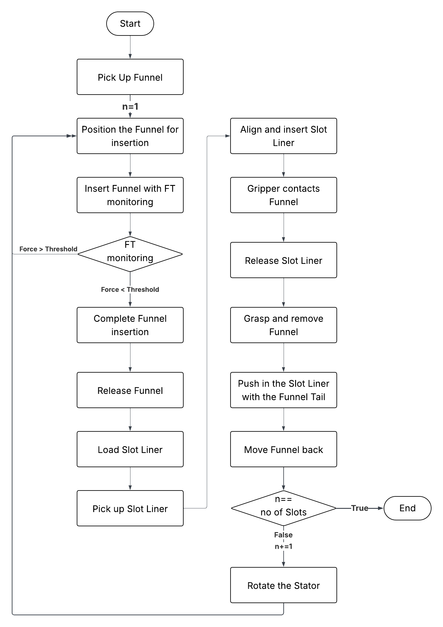

Figure ‑: Slot Liner Insertion Pipeline

## Final Liner Insertion

Following the partial insertion stage, the robot re-grasps the funnel and carefully retracts it from the stator, ensuring that the partially seated liner remains stable and correctly positioned within the slot. Once the funnel is fully removed, it is repurposed as a dedicated pushing tool for completing the insertion. Using this dual functionality eliminates the need for additional tooling while maintaining precise control over the process. The robot then applies a measured forward pressure with the funnel, gradually advancing the liner until it is fully seated and lies flush with the stator surface. This controlled approach minimizes the risk of liner deformation, guarantees proper axial placement, and ensures that the insulating barrier performs its intended protective function during motor operation. The completion of this step confirms that the liner is securely positioned, thereby finalizing the automated insertion for that slot. Immediately after, the motor-driven clamp rotates the stator to bring the next slot into position, enabling continuous and uninterrupted processing of the entire stator in an efficient cycle. The complete sequence of the slot liner insertion procedure, from funnel application to final seating, is illustrated in Figure 8.

## UR Script Based Insertion Control

The reliable execution of the slot liner insertion pipeline depends on the seamless integration between sensing hardware and motion control logic. To achieve this, the control strategy is implemented using URScript, the native scripting language of the Universal Robots platform. The robot continuously reads raw force–torque data from the integrated FT sensor, capturing all six components: translational forces (Fx, Fy, Fz) and the corresponding torques (Tx, Ty, Tz). By identifying the active insertion axis at each stage, vertical alignment along the Z-axis or horizontal insertion along the X-axis, the script selectively monitors only the relevant force component, ensuring efficient and precise control.

For example, when aligning vertically, the script monitors the Fz component and halts motion once it exceeds a predefined threshold, signaling contact with the stator. Similarly, during horizontal seating of the funnel, Fx is tracked until the appropriate force level is exceeded. This axis-specific logic simplifies the control flow and eliminates the need for complex multi-axis monitoring.

Moreover, because the function get\_tcp\_force() returns data in the base coordinate system, it is essential to convert these readings into the tool coordinate frame to align them with the direction of motion. Universal Robots offers a URScript utility: get\_tcp\_force\_tool(), together with transformation routines that enable this conversion. By incorporating these transformations, your control code can accurately interpret force inputs relative to the end-effector orientation, enhancing alignment accuracy under different part geometries or tool configurations.

This script-based, closed-loop control approach dispenses with rigid, position-based programming. The system can dynamically adjust to small variations in stator geometry or fixturing. Uniquely, URScript also supports parameterization of thresholds, insertion depths, and velocities—ensuring the pipeline retains its adaptability and flexibility. In summary, the URScript control layer effectively bridges mechanical design and sensor data, delivering consistent, precise, and configurable automated insertion suitable for varied stator designs. [65].

Having established the complete automation pipeline, including funnel placement, slot liner handling, and sensor-assisted control through URScript, the next step was to evaluate the effectiveness of the developed process in practice. A series of validation tests were therefore carried out using stators of different geometries, allowing both the adaptability of the parametric funnel design and the reliability of the insertion pipeline to be assessed under real operating conditions.

# Tool Process Testing and Validation

To evaluate the effectiveness of the proposed funnel design and automated insertion process, a series of insertion tests were performed on two stators with different geometries - namely, slot height and number of slots. One had a height of 20 mm with 36 slots, while the other had a slot height of 22 mm with 48 slots. For ease of reference, the stator with the slot height of 20 mm is referred to as stator A and the one with the slot height of 22 mm as stator B. The tests used polyester fleece slot liners which were impregnated on both sides. For each stator, the funnel design was parametrically adapted to the respective slot configuration. These customized funnel variants were then produced using 3D printing and integrated into the test setup. The slot angle (85°) and slot width (8 mm) remained the same for both stators, as the inner diameter of the stator changes. After each insertion cycle, the motorized clamp rotates the stator to align the next slot for insertion. For the stator with 36 slots, the clamp rotates in 10° increments, while for the one with 48 slots, it rotates in 7.5° increments.

## A group of green and orange pie charts AI-generated content may be incorrect.Testing results

Fig. 23 Preliminary and optimized trials for stator A and B. Each stator underwent 40 Preliminary trials and 60 Optimized trials.

The reliability and repeatability of the slot liner insertion process were evaluated through a total of 200 insertion tests on the two stators. Both the Stators underwent 100 trials each, which includes 40 preliminary trials and 60 optimized trials. During all tests, the success rates, the occurrence of defects, and the corresponding failure modes were documented. The average process cycle time was measured at 39.8 seconds at 30% speed, despite the lack of path planning or motion optimization.

## Stator A

For stator A, results summarized in figure 9 indicate an improvement in success rate from 80% in the preliminary phase to 97% following the applied process optimizations. A total of eight errors were identified during the preliminary tests. Six of these were caused by the slot liner being pulled back together with the funnel during funnel extraction. The two remaining errors were caused by the improper placement of the slot liner on the insertion platform, which led to misalignment during insertion. An overview of the error distribution can be seen in figure 10.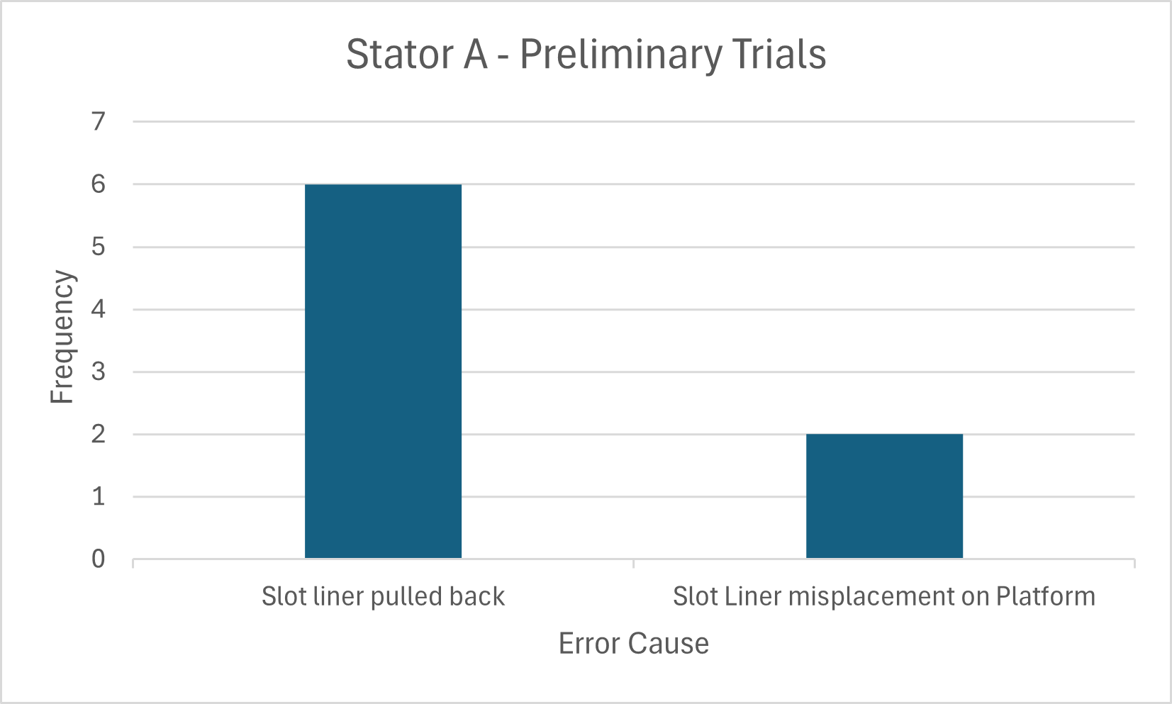

Fig. 7 Error Frequency and causes in the preliminary trials for stator A. The slot liner being pulled back with the funnel accounted for 6 errors whereas slot liner misplacement caused 2 errors.

To improve insertion reliability and eliminate the observed failure modes, several corrective measures were implemented. Firstly, the insertion procedure was standardized to ensure precise gripping and consistent alignment of the slot liners. Next, the insertion depth was increased by using the inner finger of the gripper to push the slot liner deeper into the funnel before pulling the funnel out. This technique reduced friction when retracting the funnel and improved the overall quality of the insertion. Finally, the funnel removal motion was changed from a continuous pull to a start-stop sequence. Continuous retraction often caused the funnel to become stuck or dislodge the partially inserted liner. In contrast, withdrawing the funnel in small increments reduced the likelihood of the liner being pulled back, thereby improving consistency and success rates.

After implementing these changes, the optimized test runs were carried out, which led to an increase in the success rate from 80 % to 97 %. Although the error of the slot liner being pulled back with the funnel was significantly reduced, it was not eliminated, resulting in a residual 3% error.

## Stator B

Stator B, which has a slightly larger slot height of 22 mm, was also subjected to a total of 100 insertion attempts. The increased slot height results in a slight narrowing at the upper end of the slot, making the insertion process more sensitive to the profile of the slot liner and its alignment. A total of 10 errors were identified in the preliminary tests. Of these, 9 were attributed to improper insertion. During the initial runs, the slot liners often failed to enter the slot correctly, primarily due to the slot liners not conforming to the required slot profile. One additional error occurred due to misalignment of the funnel on the platform; the graphical representation of the errors can be seen in figure 11. Care was taken to ensure that the slot liners remained consistently aligned during each test. A success rate of 77% was achieved in the preliminary tests. 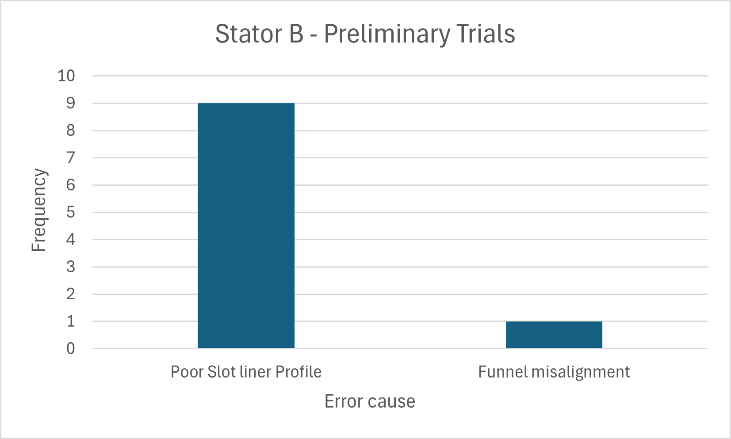

Fig. 8 Fig. 11. Error frequency and causes in the preliminary trials for stator B. Poor slot liner profile accounted for the most number of errors.

In the optimized phase, the same improvements as for Stator A, such as discontinuous retraction and deeper insertion with the gripper were applied. Interestingly, the problem observed in earlier tests with Stator A, where the slot liner was pulled back with the funnel during retraction, did not occur at all with Stator B. This may be explained not only by the optimizations made, but possibly also due to the narrower upper part of the slot, which allowed the slot liner to sit more securely and resist displacement when the funnel was retracted. In addition, repeated trials and controlled folding techniques resulted in improved profiles of the slot liner, which played a crucial role in improving insertion performance. The improved geometry and consistent alignment significantly increased the insertion success rate to 97 %, confirming the effectiveness of the optimizations made for the more geometrically constrained slots of stator B.

## Stator C

# Result Discussion

The process for inserting the slot liners was validated on two stators with different configurations: Stator A with 36 slots and Stator B with 42 slots. This means that for each complete stator, either 36 or 42 successful insertions are required to achieve complete slot lining. One of the most important results of this validation was the 97 % success rate in the optimized tests for both the stators, demonstrating a high degree of repeatability and process reliability. Compared to conventional, fully manual insertion methods, the robot-assisted approach offers several advantages.

The robot-assisted assembly significantly reduces labor and associated costs. Once optimized, the automated process also ensures consistent placement performance, thus minimizing the variability and human error that occur with manual operations. Furthermore, the system has demonstrated high flexibility and can be effectively adapted to different stator types without the need for specialized machines for each variant. This adaptability simplifies logistics and reduces investment costs, creating a scalable solution for diverse manufacturing requirements. By minimizing or eliminating manual intervention during placement, this approach increases workplace safety and reduces the risk of operator injury and fatigue. However, a key drawback to the process is the sensitivity of the process to the slot liner’s profile and condition. During the preliminary trials with Stator B, the slot liners were insufficiently pre-folded, leading to several insertion errors due to improper profiles. This highlights the need for either precisely preformed slot liners or a pre-treatment step to ensure uniform geometry prior to robot-assisted insertion.

In terms of cycle time, the process currently runs at a constant duration of 39.8 seconds per insertion operation. It should be noted that no specific optimization of the process, path planning or timing has been carried out. With appropriate motion planning and trajectory optimization, significant reductions in cycle time can be achieved, thereby improving throughput and production efficiency.

In summary, robot-assisted insertion of slot liners using a parametric funnel has great potential as a scalable, flexible, and cost-effective solution. With minor improvements in the preparation of the slot liners and optimization of cycle times, it can serve as a robust alternative to conventional manual methods in stator assembly.

# Outlook

The Parametric slot liner insertion process has proven to be very promising, as it has a high success rate and can be adapted to different Stator types. However, the current system does not automate the entire preparation cycle for slot liners – in particular, grooving, folding, and cutting. By integrating pre-folding tools and a slot lining dispenser mechanism, robustness and consistency could be significantly improved and a fully automated workflow enabled. These additions would reduce dependence on manual preparation steps and improve process reliability, especially when working with non-pre-folded inserts.

To further reduce errors, a simple image-based quality control system could be introduced to verify the alignment and profile of each slot liner before insertion. This could be enhanced by AI-powered vision systems and machine learning, allowing real-time detection of profile deviations or misalignments and dynamic adjustment of insertion paths. Altogether, expanding the system with pre-processing automation, vision-based inspection, and intelligent feedback mechanisms would transform the current setup into a more autonomous, scalable, and efficient solution suitable for industrial applications.

References

[1] P. Zhao, Z. Li, Z. Xiao, S. Jiang, Z. He, and M. Zhang, "Spatiotemporal characteristics and driving factors of CO2 emissions from road freight transportation," *Transportation Research Part D: Transport and Environment*, vol. 125, p. 103983, 2023, doi: 10.1016/j.trd.2023.103983.

[2] L. Yan, Q. Zhang, B. Zheng, and K. He, "Modeling fuel-, vehicle-type-, and age-specific CO 2 emissions from global on-road vehicles in 1970–2020," *Earth Syst. Sci. Data*, vol. 16, no. 10, pp. 4497–4509, 2024, doi: 10.5194/essd-16-4497-2024.

[3] X. Song and Y. Hao, "Emission characteristics and health effects of PM2.5 from vehicles in typical areas," *Frontiers in public health*, vol. 12, p. 1326659, 2024, doi: 10.3389/fpubh.2024.1326659.

[4] A. Mayr *et al.,* "Electric Motor Production 4.0 – Application Potentials of Industry 4.0 Technologies in the Manufacturing of Electric Motors," in *2018 8th International Electric Drives Production Conference (EDPC)*, Schweinfurt, Germany, Dec. 2018 - Dec. 2018, pp. 1–13.

[5] J. F. Hansen and F. Wendt, "History and State of the Art in Commercial Electric Ship Propulsion, Integrated Power Systems, and Future Trends," *Proc. IEEE*, vol. 103, no. 12, pp. 2229–2242, 2015, doi: 10.1109/JPROC.2015.2458990.

[6] H. A. Toliyat and G. B. Kliman, *Handbook of Electric Motors*: CRC Press, 2018. [Online]. Available: https://​books.google.de​/​books​?​id=​0Y\_MBQAAQBAJ

[7] N. T. N. Dung, "An Overview on Electric Motors: Classification, Control and Applications," *IJRSI*, XI, XI, pp. 318–333, 2024, doi: 10.51244/IJRSI.2024.11110025.

[8] *Brushless vs brushed DC motors: when and why to choose one over the other*, 2022. [Online]. Available: https://​media.monolithicpower.com​/​mps\_​cms\_​document/​2/​0/​2021-​brushless-​vs-​brushed-​dc-​motors-​when-​and-​why-​to-​choose-​one-​over-​the-​other\_​r1.0.pdf

[9] G. Pellegrino, A. Vagati, B. Boazzo, and P. Guglielmi, "Comparison of Induction and PM Synchronous Motor Drives for EV Application Including Design Examples," *IEEE Trans. on Ind. Applicat.*, vol. 48, no. 6, pp. 2322–2332, 2012, doi: 10.1109/TIA.2012.2227092.

[10] Er. Rashi Mathur Er Vikas Mathur, "A review on Analysis of Different Types of Induction Motors and Their Performance," *IJCRT - International Journal of Creative Research Thoughts (IJCRT)*, vol. 3, no. 3, 2015. [Online]. Available: https://​ijcrt.org​/​viewfulltext.php​?&​p\_id=​IJCRT1135333

[11] *Design and comparison of permanent magnet motor topologies for different application sectors*, 2021. [Online]. Available: https://​www.politesi.polimi.it​/​handle/​10589/​186694

[12] M. Chapman, N. Frost, and R. Bruetsch, "Insulation Systems for Rotating Low-Voltage Machines," in pp. 257–260.

[13] N. Boulanger *et al.,* "Aramid Based Slot Liners for Low Voltage Electric Motor Applications," in pp. 17–21.

[14] S. Y. Goh, J. Wale, and D. Greenwood, "Thermal analysis for stator slot of permanent magnet machine," in *2016 XXII International Conference on Electrical Machines (ICEM)*, Lausanne, Switzerland, Sep. 2016 - Sep. 2016, pp. 2093–2098.

[15] G. Singh and V. K. Banga, "Robots and its types for industrial applications," *Materials Today: Proceedings*, vol. 60, pp. 1779–1786, 2022, doi: 10.1016/j.matpr.2021.12.426.

[16] M. Shariatee, A. Akbarzadeh, A. Mousavi, and S. Alimardani, "Design of an economical SCARA robot for industrial applications," in pp. 534–539.

[17] Chair of Automatic Control, *Robotics.* [Online]. Available: https://​www.ac.tf.fau.eu​/​research/​robotics/​ (accessed: Aug. 1 2025).

[18] D. Seleem, M. A. Shamseldin, and H. Eleashy, "Design and Control of Delta Robot (mini review)," *Future Engineering Journal*, vol. 5, no. 1, 2025. [Online]. Available: https://​digitalcommons.aaru.edu.jo​/​fej/​vol5/​iss1/​2

[19] M. Saadeh and C. Koutsougeras, "DEVELOPMENT OF A CARTESIAN ROBOT WITH IMAGE PROCESSING AND GRASP DETECTION," in pp. 1246–1257.

[20] *UR10e.* [Online]. Available: https://​www.universal-robots.com​/​products/​ur10e/​ (accessed: Aug. 19 2025).

[21] P. Sanz, "Robotics: Modeling, Planning, and Control (Siciliano, B. et al; 2009) [On the Shelf]," *IEEE Robot. Automat. Mag.*, vol. 16, no. 4, p. 101, 2009, doi: 10.1109/MRA.2009.934833.

[22] Universal Robots, *DH Parameters for calculations of kinematics and dynamics.* [Online]. Available: https://​www.universal-robots.com​/​articles/​ur/​application-​installation/​dh-​parameters-​for-​calculations-​of-​kinematics-​and-​dynamics/​

[23] Universal Robots, *UR10e User Manual.* [Online]. Available: https://​www.universal-robots.com​/​manuals/​EN/​PDF/​SW5\_​19/​user-​manual-​UR10e-​PDF\_​online/​711-​039-​00\_​UR10e\_​User\_​Manual\_​en\_​Global.pdf (accessed: 15-072025).

[24] K. Eshraghi, P. Jiang, D. Suraci, and M. Atherton, "Preliminary Study of End-Effector Compliance for Reducing Insertion Force in Automated Fluid Coupling for Trains," *JID*, vol. 24, 3-4, pp. 139–161, 2022, doi: 10.3233/JID200017.

[25] P. Georgi, S. Ehnert, K. Güzel, and H.-C. Möhring, "Design and simulation of a multisensory-multi-process end-effector for application to various kinematics," *Procedia CIRP*, vol. 130, pp. 915–923, 2024, doi: 10.1016/j.procir.2024.10.185.

[26] M. Guo *et al.,* "Design of parallel-jaw gripper tip surfaces for robust grasping," in *2017 IEEE International Conference on Robotics and Automation (ICRA)*, Singapore, Singapore, May. 2017 - Jun. 2017, pp. 2831–2838.

[27] HITBOT, *Commonly used robotic Grippers.* [Online]. Available: https://​www.hitbotrobot.com​/​commonly-​used-​electric-​grippers/​ (accessed: Jul. 24 2025).

[28] M. Liu, L. Hao, W. Zhang, and Z. Zhao, "A novel design of shape-memory alloy-based soft robotic gripper with variable stiffness," *International Journal of Advanced Robotic Systems*, vol. 17, no. 1, 2020, doi: 10.1177/1729881420907813.

[29] On Robot, *Products and applications.* [Online]. Available: https://​onrobot.com​/​en/​products (accessed: Jul. 24 2025).

[30] *Robotics*: Springer, London, 2010.

[31] V. K. Rai, "Temperature sensors and optical sensors," (in En;en), *Appl. Phys. B*, vol. 88, no. 2, pp. 297–303, 2007, doi: 10.1007/s00340-007-2717-4.

[32] W.-P. Shih *et al.,* "Flexible Temperature Sensor Array Based on a Graphite-Polydimethylsiloxane Composite," *Sensors*, vol. 10, no. 4, pp. 3597–3610, 2010, doi: 10.3390/s100403597.

[33] Intel® RealSense™ Depth and Tracking Cameras, *Depth Camera D435i.* [Online]. Available: https://​realsenseai.com​/​stereo-​depth-​cameras/​depth-​camera-​d435i/​

[34] L. Huang *et al.,* "Research progress of multifunctional flexible proximity sensors," *Sensors and Actuators A: Physical*, vol. 360, p. 114500, 2023, doi: 10.1016/j.sna.2023.114500.

[35] T. Swedberg, "Force Torque Sensors Enhance Robotic Precision and Sensitivity," *JHFOSTER*, 07 Oct., 2025. https://​jhfoster.com​/​automation-​blogs/​force-​torque-​sensors-​enhance-​robotic-​precision-​and-​sensitivity/​ (accessed: Jul. 26 2025).

[36] Bota Systems, *What's a force torque sensor? | Bota Systems.* [Online]. Available: https://​www.botasys.com​/​post/​force-​torque-​sensor (accessed: Jul. 26 2025).

[37] G. Laudante, M. Mirto, O. Pennacchio, and S. Pirozzi, "A multi-modal sensing system for human-robot interaction through tactile and proximity data," *Front. Robot. AI*, vol. 12, p. 1581154, 2025, doi: 10.3389/frobt.2025.1581154.

[38] A. Angleraud, A. Ekrekli, K. Samarawickrama, G. Sharma, and R. Pieters, "Sensor-based human–robot collaboration for industrial tasks," *Robotics and Computer-Integrated Manufacturing*, vol. 86, p. 102663, 2024, doi: 10.1016/j.rcim.2023.102663.

[39] ISO, *ISO/TS 15066:2016.* [Online]. Available: https://​www.iso.org​/​standard/​62996.html (accessed: Jul. 26 2025).

[40] Z. Pan, J. Polden, N. Larkin, S. van Duin, and J. Norrish, "Recent progress on programming methods for industrial robots," *Robotics and Computer-Integrated Manufacturing*, vol. 28, no. 2, pp. 87–94, 2012, doi: 10.1016/j.rcim.2011.08.004.

[41] *Five ways to program a cobot.* [Online]. Available: https://​www.universal-robots.com​/​developer/​five-​ways-​to-​program-​a-​cobot/​ (accessed: Jul. 27 2025).

[42] Universal Robots, *URScript API Reference - scriptManual.* Accessed: Jul. 27 2025. [Online]. Available: https://​s3-eu-west-1.amazonaws.com​/​ur-​support-​site/​69544/​scriptManual.pdf

[43] *ROS: an open-source Robot Operating System*, 2009. [Online]. Available: http://​lars.mec.ua.pt​/​public/​lar%20projects/​binpicking/​2016\_​rodrigosalgueiro/​lib/​ros/​icraoss09-​ros.pdf

[44] A. Cherubini and D. Navarro-Alarcon, "Sensor-Based Control for Collaborative Robots: Fundamentals, Challenges, and Opportunities," *Frontiers in neurorobotics*, vol. 14, p. 576846, 2020, doi: 10.3389/fnbot.2020.576846.

[45] *ROS 2 integration paths — Universal Robots ROS 2 Driver Documentation 0.1 documentation.* [Online]. Available: https://​docs.universal-robots.com​/​Universal\_​Robots\_​ROS2\_​Documentation/​doc/​ros2\_​controller\_​vs\_​driver.html (accessed: Jul. 29 2025).

[46] *Design patterns for research methods: Iterative field research*, 2009. [Online]. Available: https://​kpratt.net​/​wp-​content/​uploads/​2009/​01/​research\_​methods.pdf

[47] BEN Buchele, *BEN Buchele Elektromotorenwerke GmbH in Nürnberg.* [Online]. Available: https://​www.benbuchele.de​/​

[48] Elmotec Statomat, *Slot Insulation - Elmotec Statomat.* [Online]. Available: https://​www.elmotec-statomat.eu​/​en/​manufacturing-​process/​slot-​insulation/​

[49] NIDE, *Automatic Stator Slot Insulation Paper Inserting Machine for Induction Motor Three Phase Motor Winding.* [Online]. Available: https://​salesdpti-nide.en.made-in-china.com​/​product/​SKpnekvGAjWL/​China-​Automatic-​Stator-​Slot-​Insulation-​Paper-​Inserting-​Machine-​for-​Induction-​Motor-​Three-​Phase-​Motor-​Winding.html

[50] GMW Taiwan, *GMW CS-2B Stator Slot Cell Inserter.* [Online]. Available: https://​www.gmwtaiwan.com​/​Slot-​Cell-​Insertion-​Machine/​GMW-​CS-​2B-​Stator-​Slot-​Cell-​Inserter

[51] *US4247978A - Methods of making slot liners and stator assemblies including same - Google Patents.* [Online]. Available: https://​patents.google.com​/​patent/​US4247978A/​en (accessed: Aug. 2 2025).

[52] D. Mayer, L. Hausmann, N. Maul, L. Reinschmidt, J. Hofmann, and J. Fleischer, "Systematic Investigation of the Grooving Process and its Influence on Slot Insulation of Stators with Hairpin Technology," in pp. 1–7.

[53] Automation International, *Flexibility and Efficiency in Small Batch Production through Automation.* [Online]. Available: https://​www.automation-mag.com​/​news/​91746-​flexibility-​and-​efficiency-​in-​small-​batch-​production-​through-​automation

[54] Y. Koren *et al.,* "Reconfigurable Manufacturing Systems," *CIRP Annals*, vol. 48, no. 2, pp. 527–540, 1999, doi: 10.1016/s0007-8506(07)63232-6.

[55] R. Wrobel, S. J. Williamson, N. Simpson, S. Ayat, J. Yon, and P. H. Mellor, "Impact of slot shape on loss and thermal behaviour of open-slot modular stator windings," in *2015 IEEE Energy Conversion Congress and Exposition (ECCE)*, Montreal, QC, Canada, Sep. 2015 - Sep. 2015, pp. 4433–4440.

[56] L. L. Wang, J. X. Shen, P. Luk, W. Z. Fei, C. F. Wang, and H. Hao, "Development of a Magnetic-Geared Permanent-Magnet Brushless Motor," *IEEE Trans. Magn.*, vol. 45, no. 10, pp. 4578–4581, 2009, doi: 10.1109/tmag.2009.2023071.

[57] The Gund Company, *Generator Slot Liner Selection Guide.* [Online]. Available: https://​thegundcompany.com​/​wp-​content/​uploads/​2024/​03/​Slot-​Liner-​Selection-​Guide-​The-​Gund-​Company.pdf (accessed: Jul. 10 2025).

[58] *Robot-based production of electric motors with hairpin winding technology*, 2019. [Online]. Available: https://​www.iaeng.org​/​publication/​wcecs2019/​wcecs2019\_​pp257-​262.pdf

[59] A. Mahr, P. Mathea, A. Vogel, A. Morello, J. Franke, and A. Kühl, "Robotic based Assembly of insulating Sleeves onto Winding Coil Ends of Electric Drive Stators," in *2023 13th International Electric Drives Production Conference (EDPC)*, 2023, pp. 1–7.

[60] V. Henrich, A. Vogel, M. Baader, J. Franke, and A. Kühl, "Vision-Based Pose Estimation of Superimposed Enameled Wire Ends for Robotic Handling of Powerdense Flat Wire Stators," in *2024 14th International Electric Drives Production Conference (EDPC)*, 2024, pp. 1–9.

[61] OnRobot, *RG2 Gripper - Flexible 2 Finger Robot Gripper | OnRobot.* [Online]. Available: https://​onrobot.com​/​us/​products/​rg2-​gripper (accessed: Aug. 20 2025).

[62] OnRobot, *Hex 6-Axis Force Torque Sensor | OnRobot.* [Online]. Available: https://​onrobot.com​/​en/​products/​hex-​6-​axis-​force-​torque-​sensor (accessed: Aug. 20 2025).

[63] M. J. Akhtar and R. K. Behera, "Optimal design of stator and rotor slot of induction motor for electric vehicle applications," *IET Electrical Systems in Transportation*, vol. 9, no. 1, pp. 35–43, 2019, doi: 10.1049/iet-est.2018.5050.

[64] A. Tokat, T. Thiringer, and E. Jansson, "Impact of stator slot geometry on the performance of a permanent magnet synchronous generator for wave energy converters," in *2020 International Conference on Electrical Machines (ICEM)*, 2020, pp. 1910–1916.

[65] *Force and torque values in tool coordinate system 44911.* [Online]. Available: https://​www.universal-robots.com​/​articles/​ur/​programming/​get-​force-​and-​torque-​values-​in-​tool-​coordinate-​system/​ (accessed: Aug. 25 2025).